
GCUF
GOVERNMENT COLLEGE UNIVERSITY FAISALABAD Final Report
Project Title:
Smart Attendance System Using Face Recognition
Submitted By:
ALI HAMZA
2022-GCUF-078847
RANA SHOAIB-UR-REHMAN
2022-GCUF-078818

Department of Computer Science
Punjab College ,Muridke
CERTIFICATE
This is to certify that RANA SHOAIB-UR-REHMAN and ALI HAMZA
2022-GCUF-078818 and 2022-GCUF-078847 have completed the final project titled as “Smart Attendance System” at the Department of Computer Science, Punjab College Muridke to fulfill the partial requirement for the degree of BS - CS. This report has not been submitted for any other examination and does not form part of any other course undergone by the candidates and qualifies for submission of project evaluation purpose.

Supervisor
Qasim Ali Signature: __________________

Project Coordinator Head of Department
Head of Department: Principal

DECLARATION

The work reported in this project was carried out by us under the supervision of Project Supervisor, Qasim Ali at Punjab College Muridke. We hereby declare that this project and the contents of project are the product of our own research and no part has been copied from any other written or published source except the references, standard mathematical or general formulas / protocol etc. We further declare that this work has not been submitted for award of any other degree / diploma. The university may take action if the provided information is found inaccurate at any stage.

ACKNOWLEDGEMENT
First of all, I am thankful to Almighty Allah for giving me the courage and ability to complete this final year project. I am also thankful to my teachers for their guidance during the development and documentation work.
I am especially thankful to my supervisor for helping me keep the project practical and clear. The guidance helped me focus on a working attendance system instead of adding unnecessary complex modules.
I also appreciate the support of friends and classmates who tested the login page, dashboard, student management page, attendance page and reports page. Their feedback helped me improve the system flow.

ABSTRACT
The Smart Attendance System Using Face Recognition is a web based final year project developed to reduce the time and mistakes involved in manual attendance. In a traditional classroom, the teacher calls student names and marks attendance manually. This process becomes slow when the class is large and it can also lead to wrong entries. The proposed system uses a camera and a face recognition process to mark attendance in a cleaner way.
The system is developed using Python FastAPI for web routing, Jinja2 templates for user interface pages, SQLite for database storage, and OpenCV models for face detection and face recognition. The application contains login, dashboard, student registration, attendance marking and report viewing modules. It also includes a simple anti-spoofing idea to reduce fake attendance using photos or screens.

Table of Contents

CHAPTER 1 INTRODUCTION 1
1.1 Background of the Project 1
1.2 Problem Statement 2
1.3 Objectives 2
1.4 Scope of the Project 2
1.5 Report Organization 3
CHAPTER 2 LITERATURE REVIEW 3
2.1 Manual Attendance Systems 3
2.2 Biometric Attendance Systems 4
2.3 Face Detection 4
2.4 Face Recognition 4
2.5 Liveness and Anti-Spoofing 5
2.6 Web Based Attendance Applications 5
2.7 Selection of Technology 6
CHAPTER 3 REQUIREMENT ANALYSIS 6
3.1 Functional Requirements 6
3.2 Non Functional Requirements 7
3.3 Hardware Requirements 8
3.4 Software Requirements 8
3.5 User Roles 8
3.6 Input and Output Requirements 9
3.7 Constraints and Assumptions 9
CHAPTER 4 SYSTEM DESIGN 10
System Architecture Diagram 10
Use Case Diagram 11
Data Flow Diagram 12
Activity Diagram for Admin 13
Activity Diagram for Student 13
Sequence Diagram for Attendance 14
Database ERD 14
Face Recognition Process Flow 15
Login and Session Flow 16
Student Enrollment Flow 16
Camera Capture to Database Flow 17
Admin and Student Role Flow 18
Work Breakdown Structure (WBS) 18
4.9 Design Notes 19
CHAPTER 5 IMPLEMENTATION 20
5.1 Project Folder Placement 20
5.2 Startup Code 22
Code Block 1: main.py application startup 22
5.3 Authentication and Roles 23
Code Block 2: auth.py session and role guards 23
5.4 Database Functions 23
Code Block 3: Database table creation 24
5.5 Attendance Capture Route 24
Code Block 4: capture-frame route 24
5.6 Liveness Checking Logic 25
Code Block 5: Liveness check logic 25
5.7 Template and Route Working 25
5.8 Implementation Notes 26
CHAPTER 6 DATABASE DESIGN AND SQL QUERIES 27
6.1 Tables in Database 27
6.2 Actual Schema Found in attendance.db 28
6.3 Important SQL Queries 28
6.4 Database Working Explanation 29
6.5 Data Dictionary 30
6.6 Database Testing Notes 30
CHAPTER 7 USER INTERFACE AND SCREENSHOTS 31
Login Screen Layout 31
Dashboard Screen Layout 32
Student Management Screen Layout 32
Attendance Screen Layout 33
Reports Screen Layout 33
7.6 Real Admin and Student Screenshots 34
7.7 UI Design Explanation 36
CHAPTER 8 TESTING AND EVALUATION 37
8.1 Testing Strategy 38
8.2 Module Testing 39
8.3 Integration Testing 39
8.4 Errors Found During Testing 40
8.5 Evaluation Summary 40
CHAPTER 9 USER MANUAL AND DEPLOYMENT 41
9.1 Installation Steps 41
9.2 Admin User Manual 41
9.3 Student User Manual 42
9.4 Operating Guidelines 42
9.5 Deployment Notes 42
CHAPTER 10 CONCLUSION AND FUTURE WORK 43
10.1 Achievements 43
10.2 Limitations 44
10.3 Future Enhancements 44
10.4 Final Remarks 44
APPENDIX A PROJECT FILE DESCRIPTION 45
APPENDIX B VIVA PREPARATION NOTES 46
APPENDIX C EXTENDED PROJECT NOTES 48
Camera Handling 48
Attendance Record Management 48
Student Registration 48
Security Improvement 49
Database Backup 49
Report Checking 49
Project Demonstration 50
Error Handling 50
Maintenance 51
Future Classroom Use 51
Software Quality 51
Teacher Workflow 52
APPENDIX D DETAILED MODULE EXPLANATION 52
Login Module 52
Dashboard Module 53
Student Management Module 53
Attendance Module 54
Report Module 55
Liveness Module 55
Face Comparison Module 56
Database Module 57
Template Module 57
Route Module 58
Upload Handling Module 58
Session Handling Module 59
APPENDIX E EXTENDED TESTING OBSERVATIONS 60
Login Testing 60
Role Access Testing 60
Student Add Testing 61
Student Delete Testing 61
Camera Testing 62
Capture Frame Testing 63
Face Match Testing 63
Spoof Block Testing 64
Report Display Testing 64
Database Query Testing 65
APPENDIX F SAMPLE MANUAL RECORD COMPARISON 65
Manual Attendance Comparison 66
Attendance Record Improvement 66
Proxy Reduction 67
Database Record Advantage 67
Final Year Demonstration Value 68
APPENDIX G ADDITIONAL EXPLANATORY NOTES 68
Admin Dashboard Behavior 68
Student Attendance Behavior 69
Camera Permission Handling 69
Face Image Quality 70
Attendance Duplicate Control 70
Report Reading Process 71
Project Backup Process 71
Viva Demonstration Flow 72
Final Submission Preparation 73
Future Maintenance Plan 73

CHAPTER 1 INTRODUCTION
Attendance is a regular activity in educational institutions and small organizations. Even though attendance is simple, it takes time when it is performed manually. The teacher or administrator has to call names, mark presence, and later manage the records. This process can become slow, especially when the number of students is large.
The Smart Attendance System Using Face Recognition is developed to make this process faster and more reliable. The system uses a camera to capture the face of a student and compares it with the registered face image. If the face is recognized, the attendance is marked automatically for the current date.
The project is made as a web application so that it can be used from a browser. The browser interface is familiar for most users and does not require a separate desktop application. The backend is written in Python and the data is stored in SQLite.
The system also includes simple login and role based access. Admin can view the dashboard, add students and view reports. Student users can access the attendance page. This keeps the application organized and prevents students from opening admin pages.
The system is planned as a local web application. This means that it can run on a laptop during the final year project demonstration. A local system is easier to test because the camera, database and web server are all available on the same machine.
The application does not require a paid cloud database. SQLite is enough for this academic version because it stores the data in one file and can be easily copied with the project folder. This makes the project easier to submit and check.
The project also focuses on understandability. The code is divided into small files such as main.py, auth.py, database.py and pages.py. The templates are stored separately in the app/templates folder. This separation makes the project easier to debug and explain.
The role based access is important because admin pages should not be opened by students. The admin can view dashboard, add students and see reports. The student side is kept limited mainly to the attendance page.
The use of real screenshots in this report shows that the application is not only a theoretical design. The screenshots show the dashboard, attendance page and student side, which proves the interface has been implemented in the browser.

1.1 Background of the Project
In the context of attendance background, the main attention was given to making the feature easy to use and easy to understand. The project is an academic prototype, so the design avoids unnecessary complexity and keeps the working steps visible to the user.
The attendance background part also supports the overall aim of reducing manual work. Instead of depending on paper registers, the application stores information in a database and allows the record to be viewed later from the report screen.
During development, the attendance background section was tested several times by opening the application in the browser and checking the result after every small change. This simple testing method helped in finding route errors, template path errors and database query mistakes.
The attendance background design is connected with other parts of the project. For example, the attendance page depends on registered students, saved face images, the camera capture process, the liveness check and the database insert query.
The final form of the attendance background module is suitable for demonstration because it shows a clear input, processing and output flow. The evaluator can see what data is entered, where it goes and how the result is shown.
If the project is improved in future, the attendance background module can be extended without changing the full system. The current design keeps the module separate enough that future improvements can be added step by step.
In the context of attendance background, the main attention was given to making the feature easy to use and easy to understand. The project is an academic prototype, so the design avoids unnecessary complexity and keeps the working steps visible to the user.

1.2 Problem Statement
Manual attendance is time consuming and sometimes inaccurate. A student can be missed, a wrong entry can be made, or the attendance register can be damaged. The record is also not easy to search if the teacher wants to check a previous date quickly.
Another problem is proxy attendance. In a normal manual system, one student may try to answer for another student. A camera based system cannot remove every possible issue, but it can reduce proxy marking by linking the attendance action with a visible face.
The project therefore focuses on a simple system that captures a face, checks it, compares it with registered students and stores the result. The system also adds a basic anti-spoofing idea to reject photos or screen images shown to the camera.

1.3 Objectives
- To develop a web based attendance system using Python and FastAPI.
- To store student and attendance data in a local SQLite database.
- To register students with name, roll number and face image.
- To capture face image from the attendance page and compare it with registered images.
- To provide admin dashboard, student management and attendance reports.
- To keep the interface simple for viva and demonstration.
- To include basic liveness checking to reduce attendance through photos or screen images.

1.4 Scope of the Project
In the context of project scope, the main attention was given to making the feature easy to use and easy to understand. The project is an academic prototype, so the design avoids unnecessary complexity and keeps the working steps visible to the user.
The project scope part also supports the overall aim of reducing manual work. Instead of depending on paper registers, the application stores information in a database and allows the record to be viewed later from the report screen.
During development, the project scope section was tested several times by opening the application in the browser and checking the result after every small change. This simple testing method helped in finding route errors, template path errors and database query mistakes.
The project scope design is connected with other parts of the project. For example, the attendance page depends on registered students, saved face images, the camera capture process, the liveness check and the database insert query.
The final form of the project scope module is suitable for demonstration because it shows a clear input, processing and output flow. The evaluator can see what data is entered, where it goes and how the result is shown.
If the project is improved in future, the project scope module can be extended without changing the full system. The current design keeps the module separate enough that future improvements can be added step by step.

1.5 Report Organization
Chapter Main Content
Chapter: 1; Main Content: Introduction and project overview
Chapter: 2; Main Content: Literature review and related ideas
Chapter: 3; Main Content: Requirement analysis
Chapter: 4; Main Content: System design and diagrams
Chapter: 5; Main Content: Implementation details with limited important code blocks
Chapter: 6; Main Content: Database design and SQL queries
Chapter: 7; Main Content: User interface and screenshots
Chapter: 8; Main Content: Testing and evaluation
Chapter: 9; Main Content: User manual and deployment
Chapter: 10; Main Content: Conclusion and future work

CHAPTER 2 LITERATURE REVIEW
Face recognition has become a common technique for identity based systems. It is used in mobile phones, access control, attendance systems and security applications. The basic idea is to capture a face, detect the face area, extract useful features and compare those features with stored records.
Traditional attendance systems include paper registers, punch cards, RFID cards and fingerprint devices. Paper registers are low cost but slow. RFID cards are faster, but cards can be shared. Fingerprint systems are accurate but require touch, which may not be suitable for every situation. Face recognition is contactless and can be used through a camera.
For this project, the literature was kept practical. Instead of studying very complex deep learning training methods, the focus was on ready-made OpenCV models that can detect and recognize faces. This choice makes the project easier to implement and easier to explain.

2.1 Manual Attendance Systems
In the context of manual attendance systems, the main attention was given to making the feature easy to use and easy to understand. The project is an academic prototype, so the design avoids unnecessary complexity and keeps the working steps visible to the user.
The manual attendance systems part also supports the overall aim of reducing manual work. Instead of depending on paper registers, the application stores information in a database and allows the record to be viewed later from the report screen.
During development, the manual attendance systems section was tested several times by opening the application in the browser and checking the result after every small change. This simple testing method helped in finding route errors, template path errors and database query mistakes.
The manual attendance systems design is connected with other parts of the project. For example, the attendance page depends on registered students, saved face images, the camera capture process, the liveness check and the database insert query.
The final form of the manual attendance systems module is suitable for demonstration because it shows a clear input, processing and output flow. The evaluator can see what data is entered, where it goes and how the result is shown.

2.2 Biometric Attendance Systems
In the context of biometric attendance systems, the main attention was given to making the feature easy to use and easy to understand. The project is an academic prototype, so the design avoids unnecessary complexity and keeps the working steps visible to the user.
The biometric attendance systems part also supports the overall aim of reducing manual work. Instead of depending on paper registers, the application stores information in a database and allows the record to be viewed later from the report screen.
During development, the biometric attendance systems section was tested several times by opening the application in the browser and checking the result after every small change. This simple testing method helped in finding route errors, template path errors and database query mistakes.
The biometric attendance systems design is connected with other parts of the project. For example, the attendance page depends on registered students, saved face images, the camera capture process, the liveness check and the database insert query.
The final form of the biometric attendance systems module is suitable for demonstration because it shows a clear input, processing and output flow. The evaluator can see what data is entered, where it goes and how the result is shown.

2.3 Face Detection
In the context of face detection, the main attention was given to making the feature easy to use and easy to understand. The project is an academic prototype, so the design avoids unnecessary complexity and keeps the working steps visible to the user.
The face detection part also supports the overall aim of reducing manual work. Instead of depending on paper registers, the application stores information in a database and allows the record to be viewed later from the report screen.
During development, the face detection section was tested several times by opening the application in the browser and checking the result after every small change. This simple testing method helped in finding route errors, template path errors and database query mistakes.
The face detection design is connected with other parts of the project. For example, the attendance page depends on registered students, saved face images, the camera capture process, the liveness check and the database insert query.
The final form of the face detection module is suitable for demonstration because it shows a clear input, processing and output flow. The evaluator can see what data is entered, where it goes and how the result is shown.

2.4 Face Recognition
In the context of face recognition, the main attention was given to making the feature easy to use and easy to understand. The project is an academic prototype, so the design avoids unnecessary complexity and keeps the working steps visible to the user.
The face recognition part also supports the overall aim of reducing manual work. Instead of depending on paper registers, the application stores information in a database and allows the record to be viewed later from the report screen.
During development, the face recognition section was tested several times by opening the application in the browser and checking the result after every small change. This simple testing method helped in finding route errors, template path errors and database query mistakes.
The face recognition design is connected with other parts of the project. For example, the attendance page depends on registered students, saved face images, the camera capture process, the liveness check and the database insert query.
The final form of the face recognition module is suitable for demonstration because it shows a clear input, processing and output flow. The evaluator can see what data is entered, where it goes and how the result is shown.

2.5 Liveness and Anti-Spoofing
In the context of liveness and anti-spoofing, the main attention was given to making the feature easy to use and easy to understand. The project is an academic prototype, so the design avoids unnecessary complexity and keeps the working steps visible to the user.
The liveness and anti-spoofing part also supports the overall aim of reducing manual work. Instead of depending on paper registers, the application stores information in a database and allows the record to be viewed later from the report screen.
During development, the liveness and anti-spoofing section was tested several times by opening the application in the browser and checking the result after every small change. This simple testing method helped in finding route errors, template path errors and database query mistakes.
The liveness and anti-spoofing design is connected with other parts of the project. For example, the attendance page depends on registered students, saved face images, the camera capture process, the liveness check and the database insert query.
The final form of the liveness and anti-spoofing module is suitable for demonstration because it shows a clear input, processing and output flow. The evaluator can see what data is entered, where it goes and how the result is shown.

2.6 Web Based Attendance Applications
In the context of web based attendance applications, the main attention was given to making the feature easy to use and easy to understand. The project is an academic prototype, so the design avoids unnecessary complexity and keeps the working steps visible to the user.
The web-based attendance applications part also supports the overall aim of reducing manual work. Instead of depending on paper registers, the application stores information in a database and allows the record to be viewed later from the report screen.
During development, the web-based attendance applications section was tested several times by opening the application in the browser and checking the result after every small change. This simple testing method helped in finding route errors, template path errors and database query mistakes.
The web based attendance applications design relates to other parts of the project. For example, the attendance page depends on registered students, saved face images, the camera capture process, the liveness check and the database insert query.
The final form of the web based attendance applications module is suitable for demonstration because it shows a clear input, processing and output flow. The evaluator can see what data is entered, where it goes and how the result is shown.

2.7 Selection of Technology
In the context of selection of technology, the main attention was given to making the feature easy to use and easy to understand. The project is an academic prototype, so the design avoids unnecessary complexity and keeps the working steps visible to the user.
The selection of technology part also supports the overall aim of reducing manual work. Instead of depending on paper registers, the application stores information in a database and allows the record to be viewed later from the report screen.
During development, the selection of technology section was tested several times by opening the application in the browser and checking the result after every small change. This simple testing method helped in finding route errors, template path errors and database query mistakes.
The selection of technology designs relates to other parts of the project. For example, the attendance page depends on registered students, saved face images, the camera capture process, the liveness check and the database insert query.
The final form of the selection of technology module is suitable for demonstration because it shows a clear input, processing and output flow. The evaluator can see what data is entered, where it goes and how the result is shown.
Technique Benefit Limitation Use in this Project
Technique: Paper register; Benefit: Very easy to use; Limitation: Slow and difficult to search; Use in this Project: Used as the problem comparison
Technique: RFID card; Benefit: Fast marking; Limitation: Card can be shared; Use in this Project: Not used because project is face based
Technique: Fingerprint; Benefit: Good identity check; Limitation: Needs touch hardware; Use in this Project: Not used in current prototype
Technique: Face recognition; Benefit: Contactless and suitable with camera; Limitation: Needs good light and camera quality; Use in this Project: Used as main attendance method
Technique: Liveness check; Benefit: Reduces photo or screen spoofing; Limitation: Not perfect in simple prototype; Use in this Project: Used as a basic anti-proxy layer

CHAPTER 3 REQUIREMENT ANALYSIS
Requirement analysis explains what the system should do and what conditions it should satisfy. In this project, requirements were written after observing the normal attendance process and then converting the process into software features.
The requirements are divided into functional requirements, non functional requirements, hardware requirements and software requirements. This makes the project easier to plan and test.

3.1 Functional Requirements
Req ID Functional Requirement
Req ID: FR-01; Functional Requirement: The system shall provide login for admin and student users.
Req ID: FR-02; Functional Requirement: The system shall create a session after successful login.
Req ID: FR-03; Functional Requirement: The admin shall view dashboard statistics.
Req ID: FR-04; Functional Requirement: The admin shall add a student with name, roll number and image.
Req ID: FR-05; Functional Requirement: The admin shall delete a student and related attendance records.
Req ID: FR-06; Functional Requirement: The system shall open the attendance page for logged in users.
Req ID: FR-07; Functional Requirement: The system shall capture a frame from camera and save it as capture.jpg.
Req ID: FR-08; Functional Requirement: The system shall perform face detection on captured image.
Req ID: FR-09; Functional Requirement: The system shall perform liveness checks before face matching.
Req ID: FR-10; Functional Requirement: The system shall compare captured face with registered student images.
Req ID: FR-11; Functional Requirement: The system shall mark attendance as Present if a match is found.
Req ID: FR-12; Functional Requirement: The system shall avoid duplicate attendance for the same student and date.
Req ID: FR-13; Functional Requirement: The admin shall view attendance records in report form.
Req ID: FR-14; Functional Requirement: The system shall show clear error messages for unknown face, no face and spoof detection.

3.2 Non Functional Requirements
Area Requirement Reason
Area: Usability; Requirement: Pages should be simple and readable; Reason: Users can operate the system without training
Area: Performance; Requirement: Attendance result should be returned in reasonable time; Reason: The system is used during class time
Area: Maintainability; Requirement: Files should be separated into modules; Reason: Errors can be found and fixed easily
Area: Portability; Requirement: System should run locally on Windows with Python; Reason: Project demonstration is usually done on laptop
Area: Security; Requirement: Admin pages should require admin role; Reason: Student should not manage records
Area: Reliability; Requirement: Database should prevent duplicate same-day attendance; Reason: Attendance report should stay clean
Area: Simplicity; Requirement: Code should remain understandable; Reason: Important for final year viva

3.3 Hardware Requirements
In the context of hardware requirements, the main attention was given to making the feature easy to use and easy to understand. The project is an academic prototype, so the design avoids unnecessary complexity and keeps the working steps visible to the user.
The hardware requirements part also supports the overall aim of reducing manual work. Instead of depending on paper registers, the application stores information in a database and allows the record to be viewed later from the report screen.
During development, the hardware requirements section was tested several times by opening the application in the browser and checking the result after every small change. This simple testing method helped in finding route errors, template path errors and database query mistakes.
The hardware requirements design is connected with other parts of the project. For example, the attendance page depends on registered students, saved face images, the camera capture process, the liveness check and the database insert query.
The final form of the hardware requirements module is suitable for demonstration because it shows a clear input, processing and output flow. The evaluator can see what data is entered, where it goes and how the result is shown.

3.4 Software Requirements
In the context of software requirements, the main attention was given to making the feature easy to use and easy to understand. The project is an academic prototype, so the design avoids unnecessary complexity and keeps the working steps visible to the user.
The software requirements part also supports the overall aim of reducing manual work. Instead of depending on paper registers, the application stores information in a database and allows the record to be viewed later from the report screen.
During development, the software requirements section was tested several times by opening the application in the browser and checking the result after every small change. This simple testing method helped in finding route errors, template path errors and database query mistakes.
The software requirements design is connected with other parts of the project. For example, the attendance page depends on registered students, saved face images, the camera capture process, the liveness check and the database insert query.
The final form of the software requirements module is suitable for demonstration because it shows a clear input, processing and output flow. The evaluator can see what data is entered, where it goes and how the result is shown.

3.5 User Roles
In the context of user roles, the main attention was given to making the feature easy to use and easy to understand. The project is an academic prototype, so the design avoids unnecessary complexity and keeps the working steps visible to the user.
The user roles part also supports the overall aim of reducing manual work. Instead of depending on paper registers, the application stores information in a database and allows the record to be viewed later from the report screen.
During development, the user roles section was tested several times by opening the application in the browser and checking the result after every small change. This simple testing method helped in finding route errors, template path errors and database query mistakes.
The user roles design is connected with other parts of the project. For example, the attendance page depends on registered students, saved face images, the camera capture process, the liveness check and the database insert query.
The final form of the user roles module is suitable for demonstration because it shows a clear input, processing and output flow. The evaluator can see what data is entered, where it goes and how the result is shown.

3.6 Input and Output Requirements
In the context of input and output requirements, the main attention was given to making the feature easy to use and easy to understand. The project is an academic prototype, so the design avoids unnecessary complexity and keeps the working steps visible to the user.
The input and output requirements part also supports the overall aim of reducing manual work. Instead of depending on paper registers, the application stores information in a database and allows the record to be viewed later from the report screen.
During development, the input and output requirements section was tested several times by opening the application in the browser and checking the result after every small change. This simple testing method helped in finding route errors, template path errors and database query mistakes.
The input and output requirements design is connected with other parts of the project. For example, the attendance page depends on registered students, saved face images, the camera capture process, the liveness check and the database insert query.
The final form of the input and output requirements module is suitable for demonstration because it shows a clear input, processing and output flow. The evaluator can see what data is entered, where it goes and how the result is shown.

3.7 Constraints and Assumptions
In the context of constraints and assumptions, the main attention was given to making the feature easy to use and easy to understand. The project is an academic prototype, so the design avoids unnecessary complexity and keeps the working steps visible to the user.
The constraints and assumptions part also supports the overall aim of reducing manual work. Instead of depending on paper registers, the application stores information in a database and allows the record to be viewed later from the report screen.
During development, the constraints and assumptions section was tested several times by opening the application in the browser and checking the result after every small change. This simple testing method helped in finding route errors, template path errors and database query mistakes.
The constraints and assumptions design is connected with other parts of the project. For example, the attendance page depends on registered students, saved face images, the camera capture process, the liveness check and the database insert query.
The final form of the constraints and assumptions module is suitable for demonstration because it shows a clear input, processing and output flow. The evaluator can see what data is entered, where it goes and how the result is shown.

Role Allowed Pages Main Responsibility
Role: Admin; Allowed Pages: Dashboard, Students, Attendance, Reports; Main Responsibility: Manage students and review attendance
Role: Student; Allowed Pages: Attendance; Main Responsibility: Open attendance page and mark attendance
Role: System; Allowed Pages: Background processing; Main Responsibility: Check login, process image, update database

Component Minimum Requirement Recommended
Component: Processor; Minimum Requirement: Core i3 or equivalent; Recommended: Core i5 or better
Component: RAM; Minimum Requirement: 4 GB; Recommended: 8 GB
Component: Camera; Minimum Requirement: Basic webcam; Recommended: HD webcam
Component: Storage; Minimum Requirement: 500 MB free; Recommended: 1 GB free
Component: Operating System; Minimum Requirement: Windows 10; Recommended: Windows 10/11

Software Purpose
Software: Python; Purpose: Main programming language
Software: FastAPI; Purpose: Backend web framework
Software: Uvicorn; Purpose: Development server
Software: Jinja2; Purpose: HTML template rendering
Software: SQLite; Purpose: Local database
Software: OpenCV; Purpose: Face detection and recognition
Software: HTML/CSS/Bootstrap; Purpose: Frontend interface
Software: VS Code; Purpose: Development environment

CHAPTER 4 SYSTEM DESIGN
System design converts the requirements into a clear structure. It explains how the system parts are connected and how data moves from the browser to the backend and then to the database.
The diagrams used in this chapter are intentionally simple. They look like diagrams made inside MS Word, because the aim is to make them easy to understand instead of making them visually complicated.

System Architecture Diagram
In the context of system architecture diagram, the main attention was given to making the feature easy to use and easy to understand. The project is an academic prototype, so the design avoids unnecessary complexity and keeps the working steps visible to the user.
The system architecture diagram part also supports the overall aim of reducing manual work. Instead of depending on paper registers, the application stores information in a database and allows the record to be viewed later from the report screen.
During development, the system architecture diagram section was tested several times by opening the application in the browser and checking the result after every small change. This simple testing method helped in finding route errors, template path errors and database query mistakes.
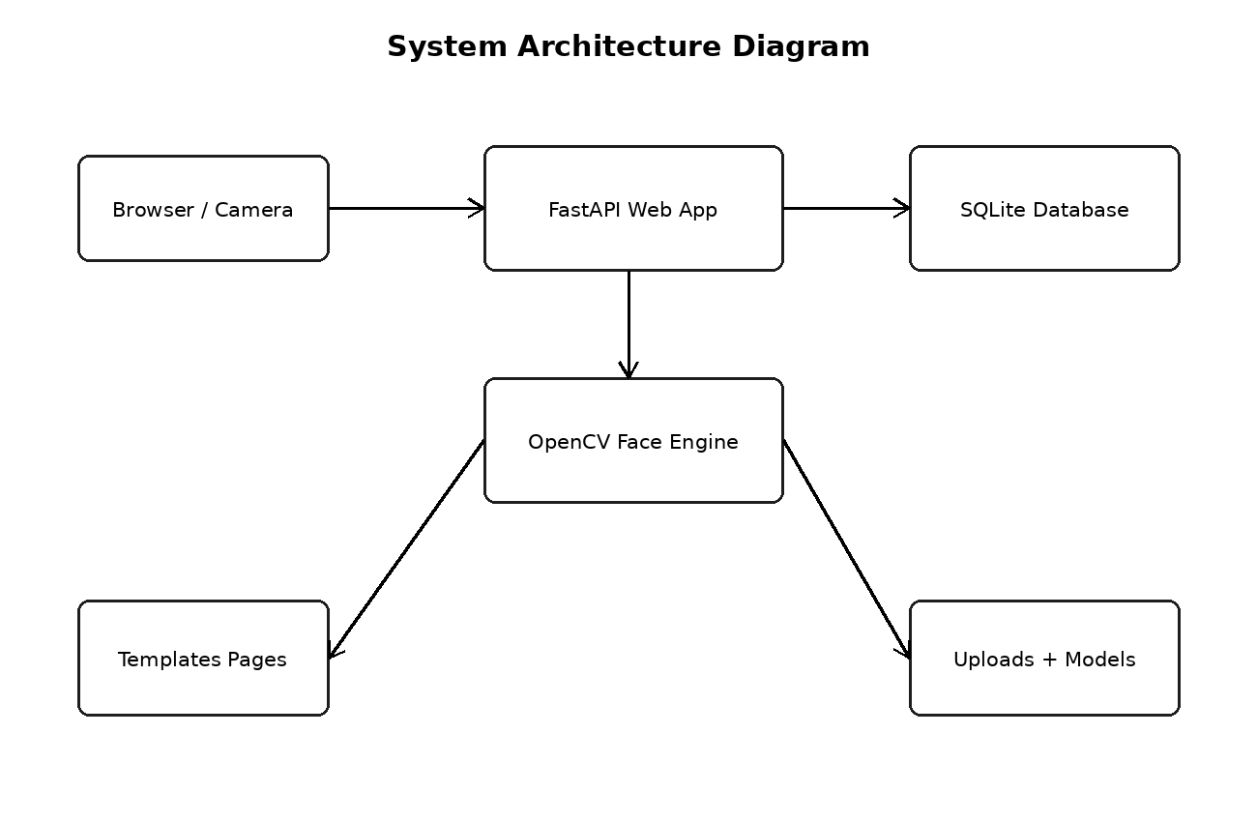
Figure 1: System Architecture Diagram

Use Case Diagram
In the context of use case diagram, the main attention was given to making the feature easy to use and easy to understand. The project is an academic prototype, so the design avoids unnecessary complexity and keeps the working steps visible to the user.
The use case diagram part also supports the overall aim of reducing manual work. Instead of depending on paper registers, the application stores information in a database and allows the record to be viewed later from the report screen.
During development, the use case diagram section was tested several times by opening the application in the browser and checking the result after every small change. This simple testing method helped in finding route errors, template path errors and database query mistakes.
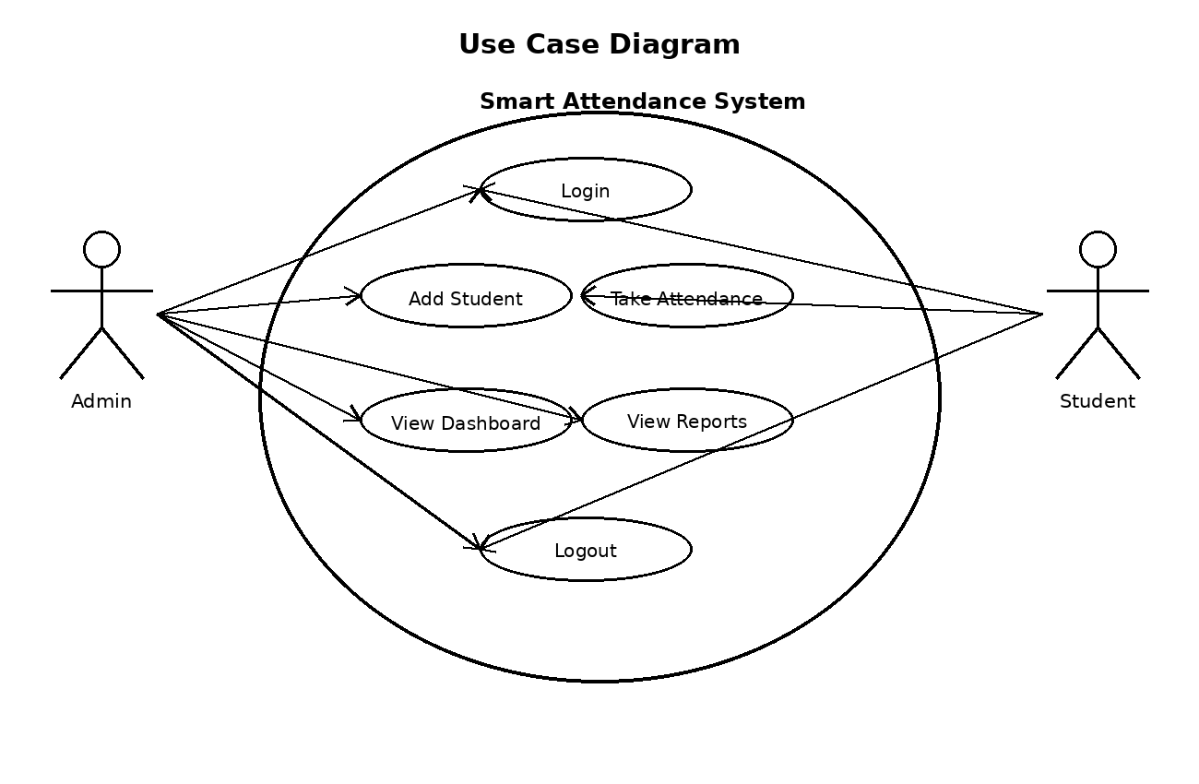
Figure 2: Use Case Diagram

Data Flow Diagram
In the context of data flow diagram, the main attention was given to making the feature easy to use and easy to understand. The project is an academic prototype, so the design avoids unnecessary complexity and keeps the working steps visible to the user.
The data flow diagram part also supports the overall aim of reducing manual work. Instead of depending on paper registers, the application stores information in a database and allows the record to be viewed later from the report screen.
During development, the data flow diagram section was tested several times by opening the application in the browser and checking the result after every small change. This simple testing method helped in finding route errors, template path errors and database query mistakes.
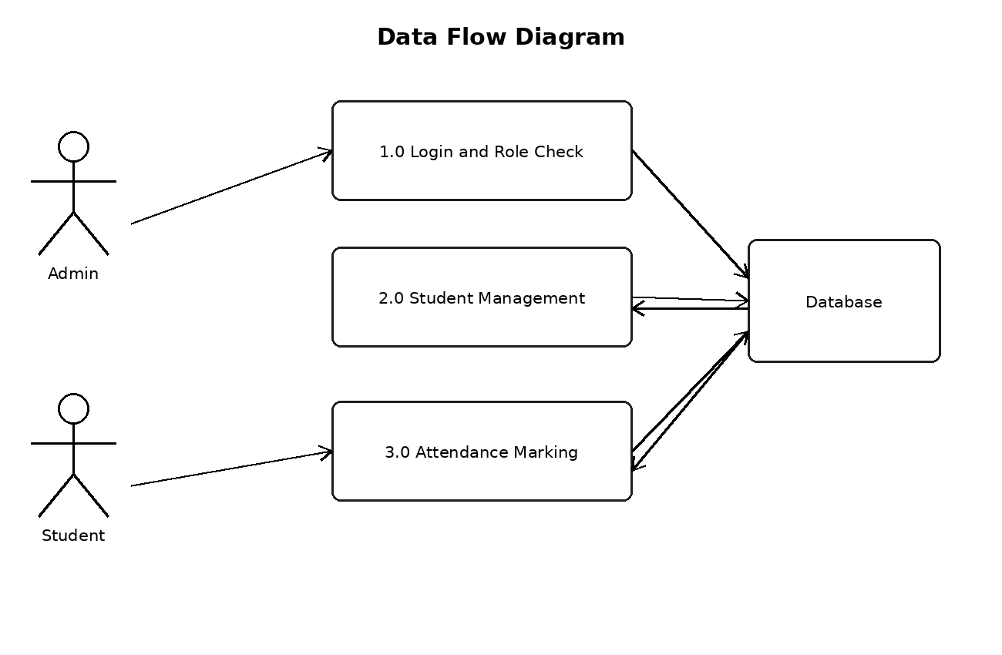
Figure 3: Data Flow Diagram

Activity Diagram for Admin
In the context of activity diagram for admin, the main attention was given to making the feature easy to use and easy to understand. The project is an academic prototype, so the design avoids unnecessary complexity and keeps the working steps visible to the user.
The activity diagram for admin part also supports the overall aim of reducing manual work. Instead of depending on paper registers, the application stores information in a database and allows the record to be viewed later from the report screen.
During development, the activity diagram for admin section was tested several times by opening the application in the browser and checking the result after every small change. This simple testing method helped in finding route errors, template path errors and database query mistakes.
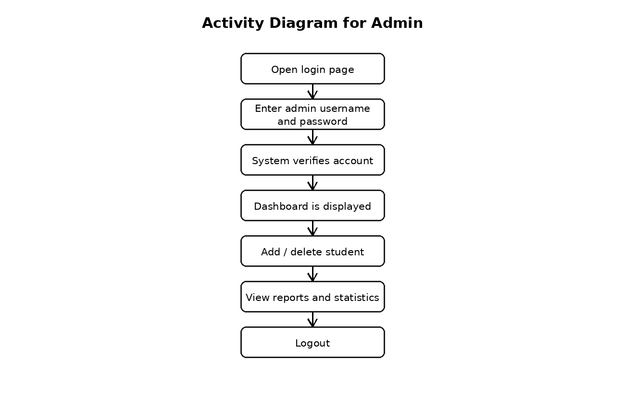
Figure 4: Activity Diagram for Admin

Activity Diagram for Student
In the context of activity diagram for student, the main attention was given to making the feature easy to use and easy to understand. The project is an academic prototype, so the design avoids unnecessary complexity and keeps the working steps visible to the user.
The activity diagram for student part also supports the overall aim of reducing manual work. Instead of depending on paper registers, the application stores information in a database and allows the record to be viewed later from the report screen.
During development, the activity diagram for student section was tested several times by opening the application in the browser and checking the result after every small change. This simple testing method helped in finding route errors, template path errors and database query mistakes.
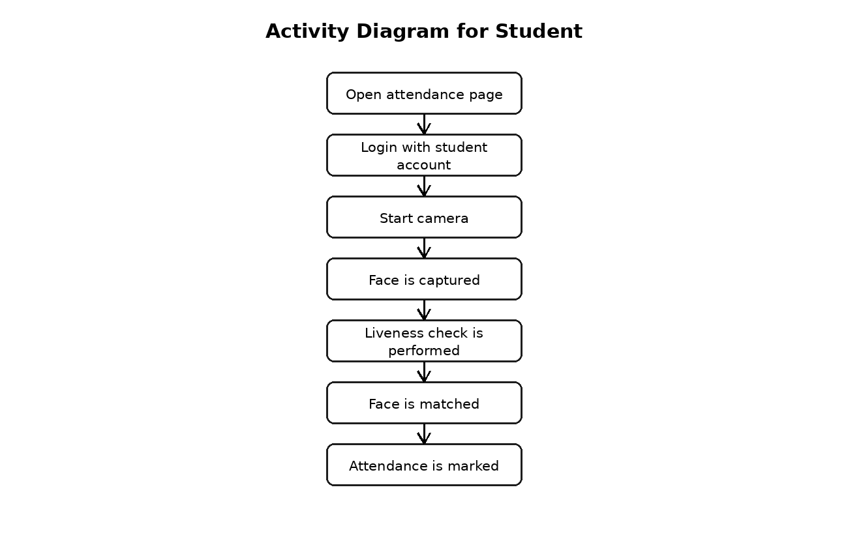
Figure 5: Activity Diagram for Student

Sequence Diagram for Attendance
In the context of sequence diagram for attendance, the main attention was given to making the feature easy to use and easy to understand. The project is an academic prototype, so the design avoids unnecessary complexity and keeps the working steps visible to the user.
The sequence diagram for attendance part also supports the overall aim of reducing manual work. Instead of depending on paper registers, the application stores information in a database and allows the record to be viewed later from the report screen.
During development, the sequence diagram for attendance section was tested several times by opening the application in the browser and checking the result after every small change. This simple testing method helped in finding route errors, template path errors and database query mistakes.
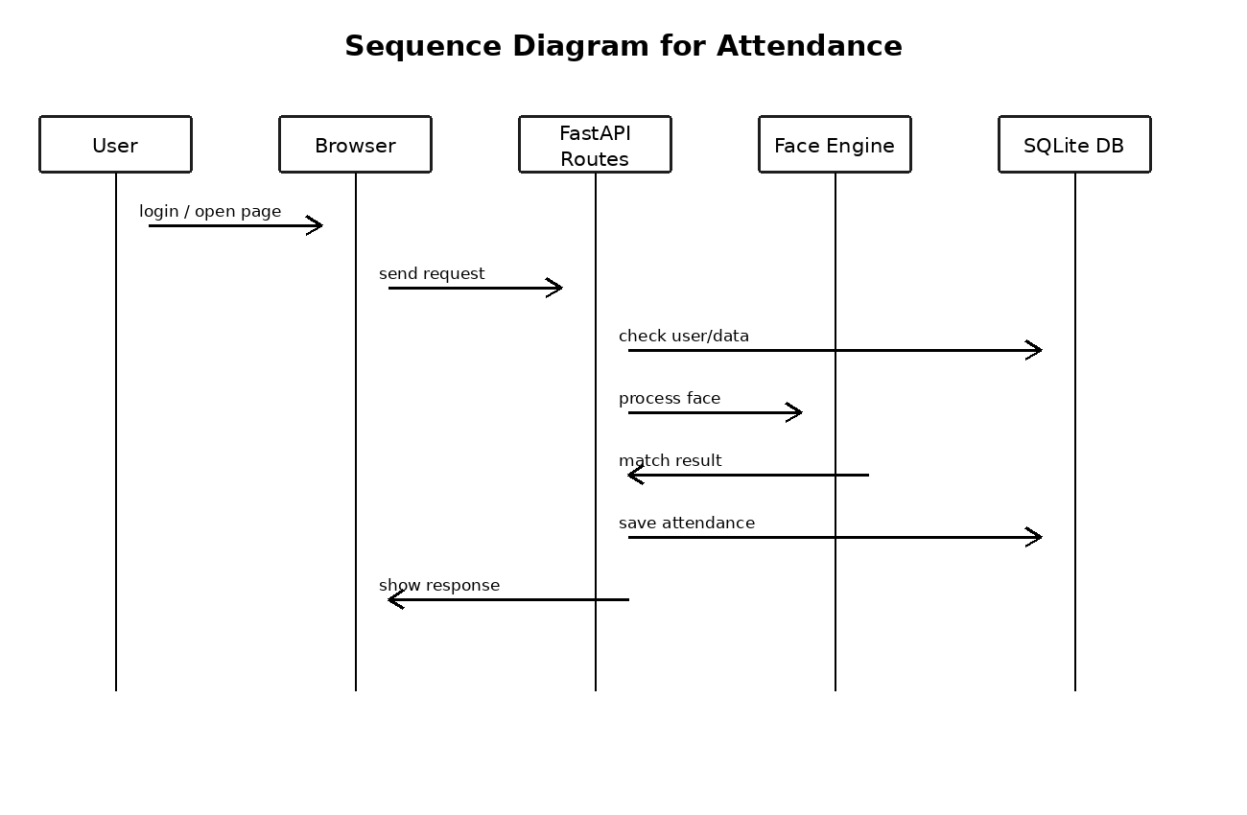
Figure 6: Sequence Diagram for Attendance

Database ERD
The corrected ERD shows the real database structure used in the Smart Attendance project. It includes the users table for login and roles, the students table for enrolled students, and the attendance table for date-wise attendance records.
The main database relationship is one student to many attendance records. The users table is separate because it handles authentication and role control, not student biometric records.
This corrected design avoids unnecessary entities and matches the current SQLite implementation used in the prototype.
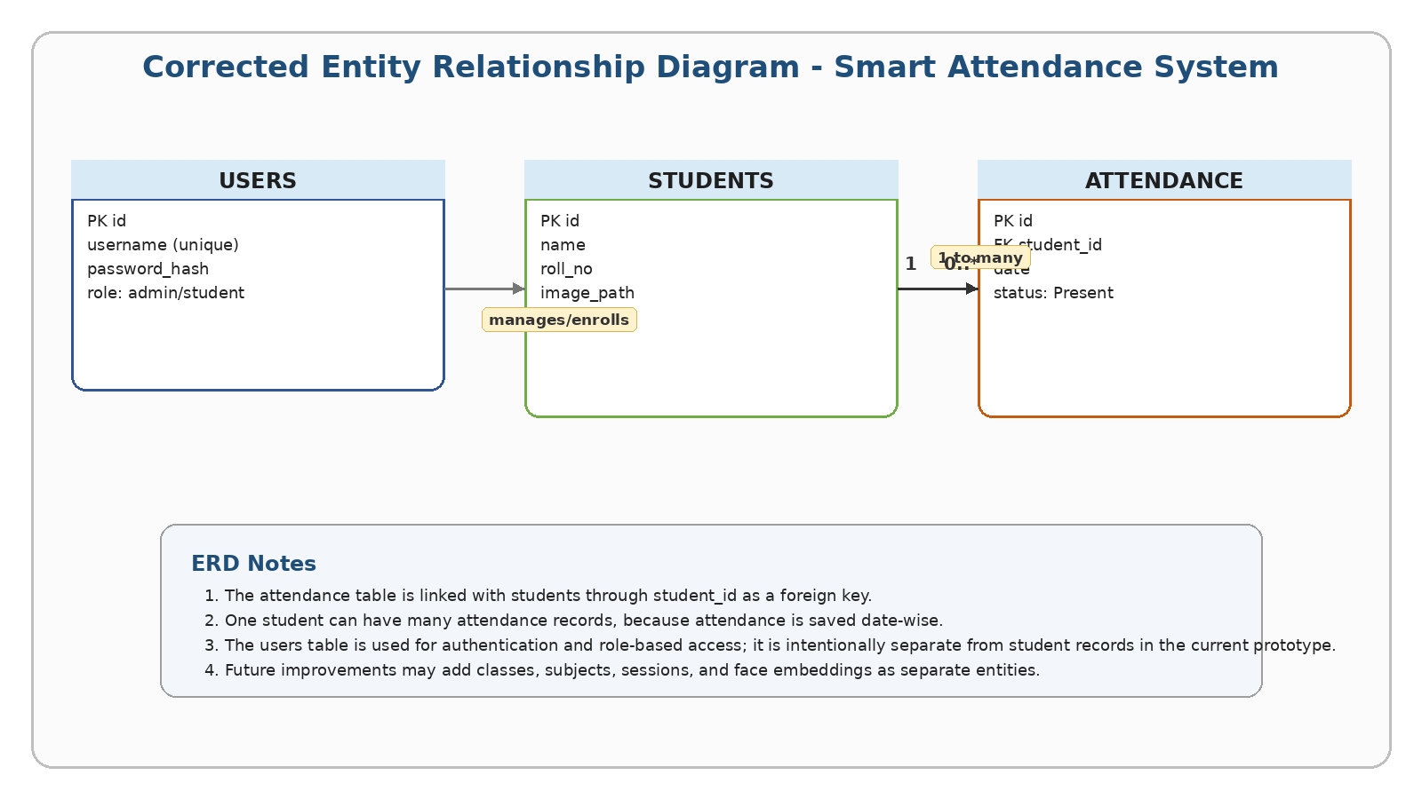
Figure 7: Database ERD

Face Recognition Process Flow
In the context of face recognition process flow, the main attention was given to making the feature easy to use and easy to understand. The project is an academic prototype, so the design avoids unnecessary complexity and keeps the working steps visible to the user.
The face recognition process flow part also supports the overall aim of reducing manual work. Instead of depending on paper registers, the application stores information in a database and allows the record to be viewed later from the report screen.
During development, the face recognition process flow section was tested several times by opening the application in the browser and checking the result after every small change. This simple testing method helped in finding route errors, template path errors and database query mistakes.
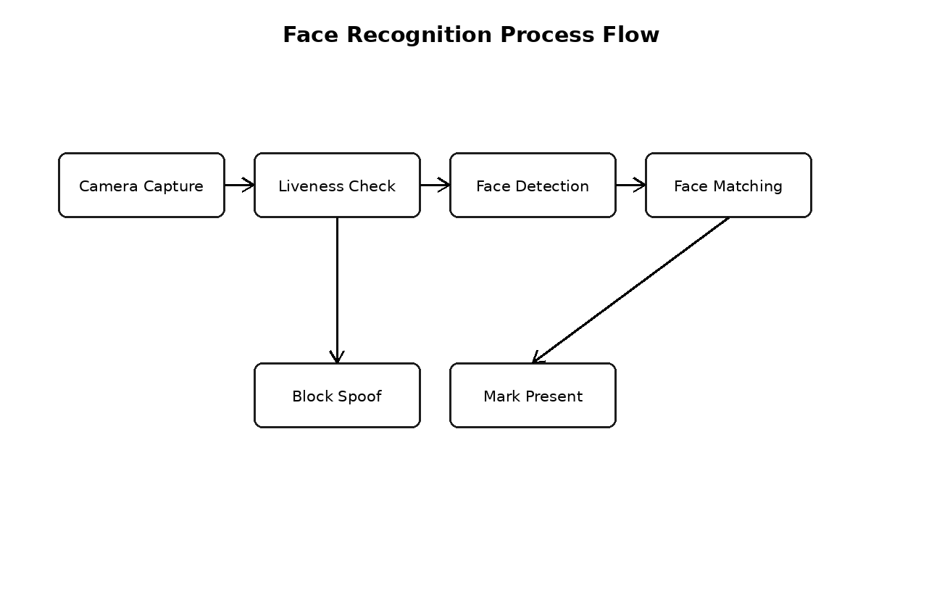
Figure 8: Face Recognition Process Flow

Login and Session Flow
In the context of login and session flow, the main attention was given to making the feature easy to use and easy to understand. The project is an academic prototype, so the design avoids unnecessary complexity and keeps the working steps visible to the user.
The login and session flow part also supports the overall aim of reducing manual work. Instead of depending on paper registers, the application stores information in a database and allows the record to be viewed later from the report screen.
During development, the login and session flow section was tested several times by opening the application in the browser and checking the result after every small change. This simple testing method helped in finding route errors, template path errors and database query mistakes.
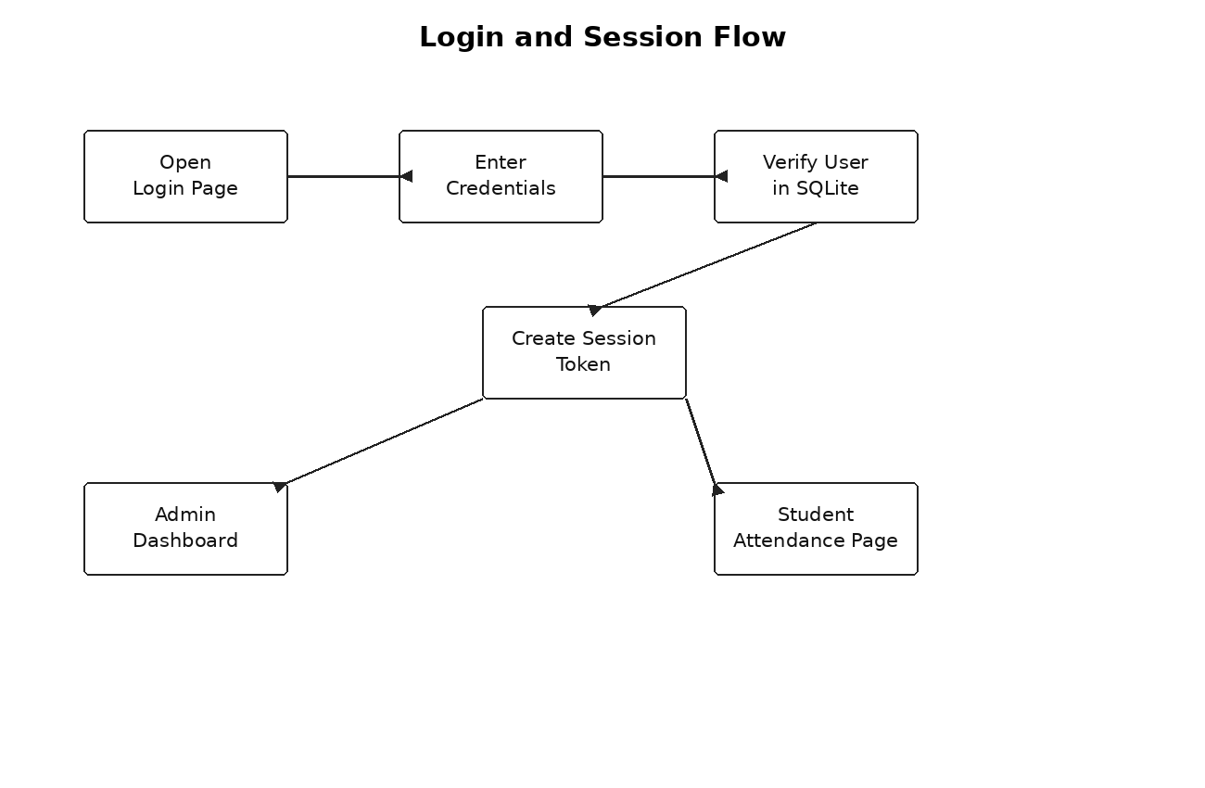
Figure 9: Login and Session Flow

Student Enrollment Flow
In the context of student enrollment flow, the main attention was given to making the feature easy to use and easy to understand. The project is an academic prototype, so the design avoids unnecessary complexity and keeps the working steps visible to the user.
The student enrollment flow part also supports the overall aim of reducing manual work. Instead of depending on paper registers, the application stores information in a database and allows the record to be viewed later from the report screen.
During development, the student enrollment flow section was tested several times by opening the application in the browser and checking the result after every small change. This simple testing method helped in finding route errors, template path errors and database query mistakes.
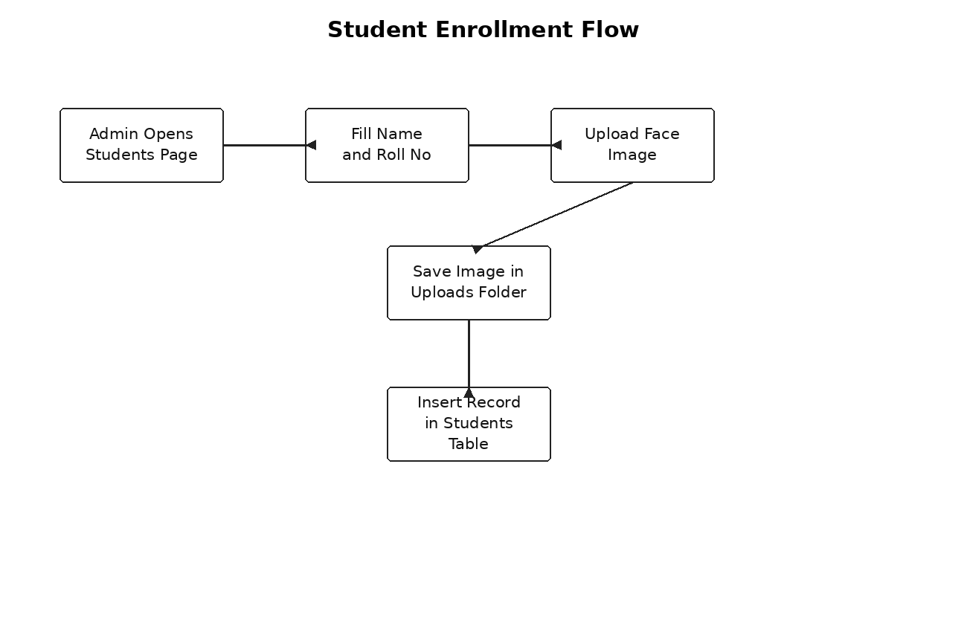
Figure 10: Student Enrollment Flow

Camera Capture to Database Flow
In the context of camera capture to database flow, the main attention was given to making the feature easy to use and easy to understand. The project is an academic prototype, so the design avoids unnecessary complexity and keeps the working steps visible to the user.
The camera capture to database flow part also supports the overall aim of reducing manual work. Instead of depending on paper registers, the application stores information in a database and allows the record to be viewed later from the report screen.
During development, the camera capture to database flow section was tested several times by opening the application in the browser and checking the result after every small change. This simple testing method helped in finding route errors, template path errors and database query mistakes.
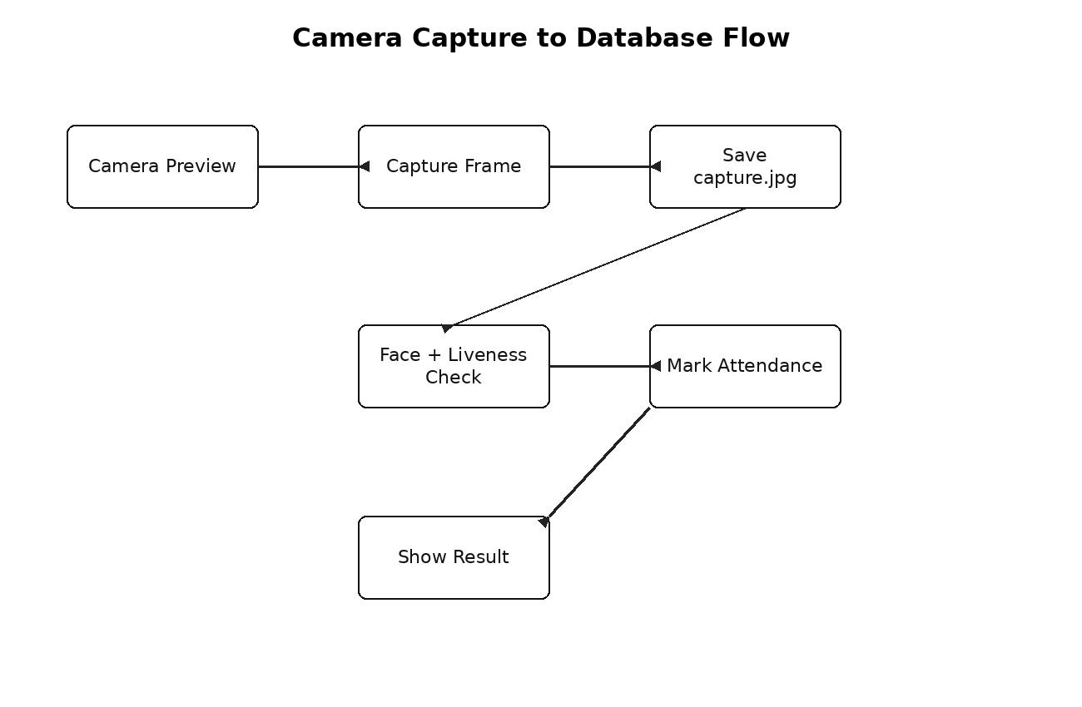
Figure 11: Camera Capture to Database Flow

Admin and Student Role Flow
In the context of admin and student role flow, the main attention was given to making the feature easy to use and easy to understand. The project is an academic prototype, so the design avoids unnecessary complexity and keeps the working steps visible to the user.
The admin and student role flow part also supports the overall aim of reducing manual work. Instead of depending on paper registers, the application stores information in a database and allows the record to be viewed later from the report screen.
During development, the admin and student role flow section was tested several times by opening the application in the browser and checking the result after every small change. This simple testing method helped in finding route errors, template path errors and database query mistakes.
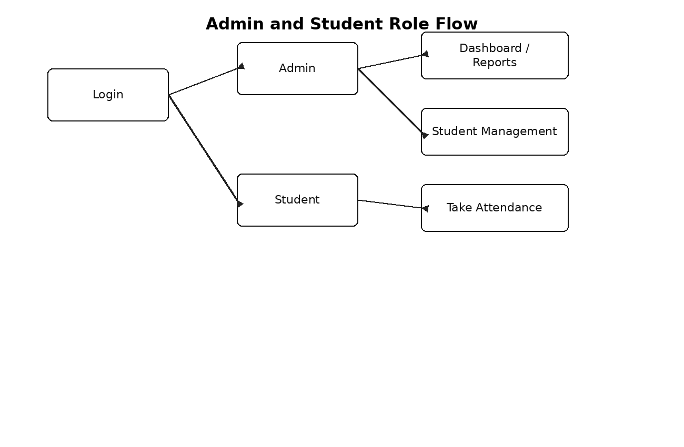
Figure 12: Admin and Student Role Flow

Work Breakdown Structure (WBS)
The Work Breakdown Structure divides the Smart Attendance project into smaller manageable parts. It shows how the project work was planned from requirement analysis to design, implementation, testing and final documentation.
The WBS is useful for final year project documentation because it explains the project scope in a structured way and helps evaluators understand the work distribution.
Each branch represents a major work package, while the lower boxes represent the important tasks completed under that package.
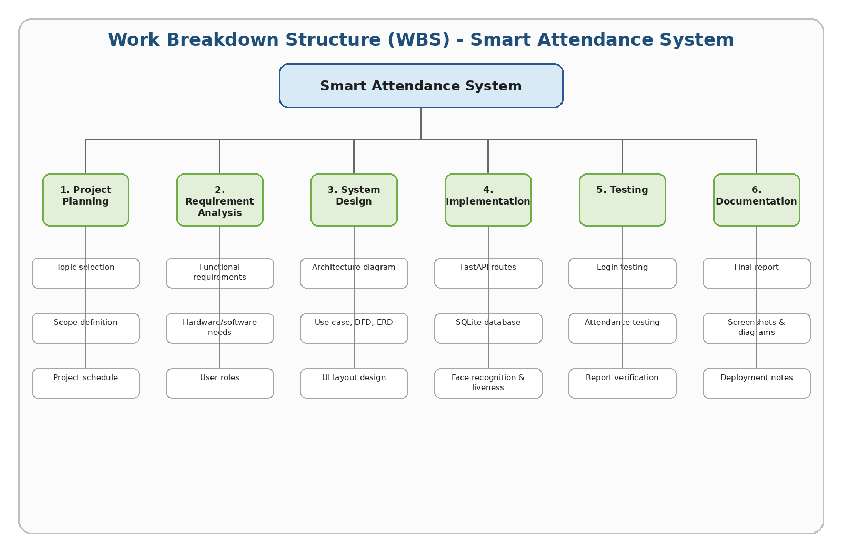
Figure 13: Work Breakdown Structure (WBS)

4.9 Design Notes
In the context of design notes, the main attention was given to making the feature easy to use and easy to understand. The project is an academic prototype, so the design avoids unnecessary complexity and keeps the working steps visible to the user.
The design notes part also support the overall aim of reducing manual work. Instead of depending on paper registers, the application stores information in a database and allows the record to be viewed later from the report screen.
During development, the design notes section was tested several times by opening the application in the browser and checking the result after every small change. This simple testing method helped in finding route errors, template path errors and database query mistakes.
The design notes design is connected with other parts of the project. For example, the attendance page depends on registered students, saved face images, the camera capture process, the liveness check and the database insert query.
The final form of the design notes module is suitable for demonstration because it shows a clear input, processing and output flow. The evaluator can see what data is entered, where it goes and how the result is shown.
If the project is improved in future, the design notes module can be extended without changing the full system. The current design keeps the module separate enough that future improvements can be added step by step.
In the context of design notes, the main attention was given to making the feature easy to use and easy to understand. The project is an academic prototype, so the design avoids unnecessary complexity and keeps the working steps visible to the user.
The design notes part also supports the overall aim of reducing manual work. Instead of depending on paper registers, the application stores information in a database and allows the record to be viewed later from the report screen.

CHAPTER 5 IMPLEMENTATION
Implementation is the stage where the design is converted into actual working files. The project implementation is divided into application startup, authentication, database functions, page routes, camera capture and face matching.
Only the most necessary code blocks are included in this report. The purpose is not to paste the complete project source code. The purpose is to explain the important working parts that are required for viva and evaluation.

5.1 Project Folder Placement
The current folder placement keeps the FastAPI application inside the app folder. The routes folder contains pages.py and the templates folder contains all HTML pages. The attendance.db file and database.py file are kept in the project root. The uploads folder stores captured images and registered face images.
The following real screenshots show the current placement of folders and files as used during development. These screenshots are included so the evaluator can see the actual structure of the submitted project.
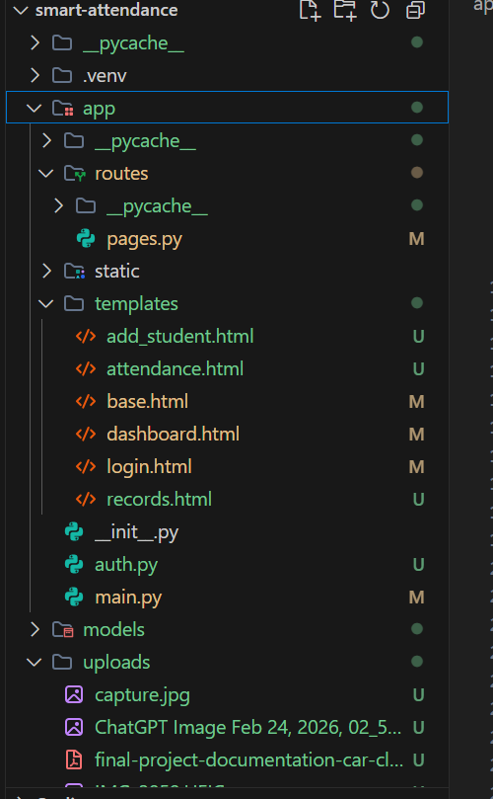
Real screenshot: Current project folder placement in VS Code - app, routes, templates, static and uploads
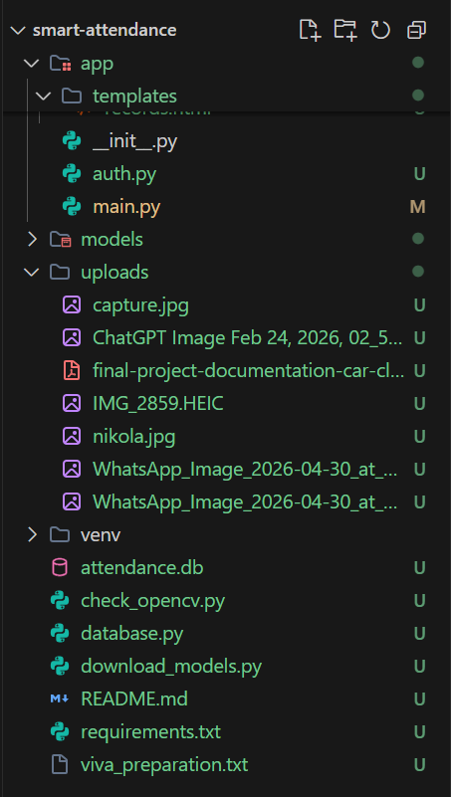
Real screenshot: Project root files including attendance.db, database.py, requirements.txt and README.md

5.2 Startup Code
The startup code creates the FastAPI application, creates database tables, adds default users and mounts required folders. This is the first important block because the whole application depends on it.
The static and uploads folders are mounted so that browser pages can access styles and uploaded images. The router from app.routes.pages is included to connect all page routes with the main application.

Code Block 1: main.py application startup
from fastapi import FastAPI
from fastapi.staticfiles import StaticFiles
from .routes.pages import router as pages_router
from database import create_database, seed_default_users

app = FastAPI(title="Smart Attendance")
create_database()
seed_default_users()

app.mount("/static", StaticFiles(directory="app/static"), name="static")
app.include_router(pages_router)

app.mount("/uploads", StaticFiles(directory="uploads"), name="uploads")

5.3 Authentication and Roles
Authentication is handled by creating a random session token after successful login. The token is stored in a browser cookie and the server keeps the token details in an in-memory sessions dictionary.
The project uses two main guards: require_login and require_admin. The first guard checks whether a user is logged in. The second guard checks whether the logged in user has the admin role. This protects admin pages from normal student access.

Code Block 2: auth.py session and role guards
import uuid
from fastapi import Request
from fastapi.responses import RedirectResponse

# In-memory session store: { token: { "username": ..., "role": ... } }
sessions = {}

def create_session(username: str, role: str) -> str:
"""Create a new session and return its token."""
token = str(uuid.uuid4())
sessions[token] = {"username": username, "role": role}
return token

def get_current_user(request: Request):
"""Return the logged-in user dict, or None if not authenticated."""
token = request.cookies.get("session_token")
if token and token in sessions:
return sessions[token]
return None

def destroy_session(request: Request):
"""Remove the session associated with this request."""
token = request.cookies.get("session_token")
if token and token in sessions:
del sessions[token]

def require_login(request: Request):
"""Return a redirect response if user is not logged in, else None."""
if get_current_user(request) is None:
return RedirectResponse(url="/?error=Please+log+in+first", status_code=302)
return None

5.4 Database Functions
The database functions are placed in database.py. This file creates tables and provides helper functions for adding students, reading students, marking attendance, counting dashboard values and displaying reports.
SQLite was selected because it is easy to use in a final year project. It does not require server configuration and the database is stored in one attendance.db file.

Code Block 3: Database table creation
def create_database():
conn = get_connection()
cursor = conn.cursor()

cursor.execute("""
CREATE TABLE IF NOT EXISTS students (
id INTEGER PRIMARY KEY AUTOINCREMENT,
name TEXT NOT NULL,
roll_no TEXT NOT NULL,
image_path TEXT
)
""")

cursor.execute("""
CREATE TABLE IF NOT EXISTS attendance (
id INTEGER PRIMARY KEY AUTOINCREMENT,
student_id INTEGER,
date TEXT,
status TEXT,
FOREIGN KEY (student_id) REFERENCES students(id)
)
""")

cursor.execute("""
CREATE TABLE IF NOT EXISTS users (
id INTEGER PRIMARY KEY AUTOINCREMENT,
username TEXT NOT NULL UNIQUE,
password_hash TEXT NOT NULL,
role TEXT NOT NULL CHECK(role IN ('admin', 'student'))
)
""")

conn.commit()
conn.close()

5.5 Attendance Capture Route
The capture-frame route receives an image from the browser camera. The image is saved as uploads/capture.jpg. After saving the image, the backend calls recognize_student_from_capture. If a student id is returned, the system marks attendance for the current date.
This route is important because it connects frontend camera work with backend face recognition and database insertion. It also returns a JSON message so the attendance page can show the result to the user.

Code Block 4: capture-frame route
@router.post("/capture-frame")
async def capture_frame(request: Request, frame: UploadFile = File(...)):
guard = require_login(request)
if guard:
return JSONResponse({"message": "Not authenticated"}, status_code=401)
try:
os.makedirs("uploads", exist_ok=True)
save_path = "uploads/capture.jpg"

content = await frame.read()
with open(save_path, "wb") as f:
f.write(content)

sid, message = recognize_student_from_capture()

if sid is not None:
today = str(date.today())
mark_attendance(sid, today, "Present")

return JSONResponse({"message": message})

except Exception as e:
return JSONResponse({"message": f"Server error: {str(e)}"})

5.6 Liveness Checking Logic
The liveness function is included to reduce fake attendance through photos or screens. It uses four checks: blur/texture, frequency pattern, color variation and glare. A face must pass at least three checks to be considered live.
This is a basic academic liveness method. It is not equal to a commercial biometric anti-spoofing system, but it is enough to demonstrate the idea of blocking simple proxy attempts during the project demonstration.

Code Block 5: Liveness check logic
def check_liveness(image_path):
"""Multi-check anti-spoofing: detects photos/screens shown to the camera.

Uses 4 independent checks:
1. Laplacian blur — real faces have natural texture (threshold 80)
2. High-frequency energy — screens produce moiré patterns
3. Color saturation — screens have unnaturally uniform colors
4. Specular highlights — screens produce bright glare spots

A face must pass at least 3 of 4 checks to be considered live.
"""
img = cv2.imread(image_path)
if img is None:
return False, 0

gray = cv2.cvtColor(img, cv2.COLOR_BGR2GRAY)
height, width = img.shape[:2]

detector = cv2.FaceDetectorYN.create(FACE_DETECT_MODEL, "", (width, height))
_, faces = detector.detect(img)

if faces is None or len(faces) == 0:
return False, 0

face = faces[0]
x, y, w, h = int(face[0]), int(face[1]), int(face[2]), int(face[3])
x = max(0, x)
y = max(0, y)
w = min(w, width - x)
h = min(h, height - y)

face_crop = gray[y:y+h, x:x+w]
face_crop_color = img[y:y+h, x:x+w]
if face_crop.size == 0:
return False, 0

checks_passed = 0
details = []

# --- Check 1: Laplacian variance (blur detection) ---
laplacian = cv2.Laplacian(face_crop, cv2.CV_64F)
lap_score = laplacian.var()

5.7 Template and Route Working
In the context of template and route working, the main attention was given to making the feature easy to use and easy to understand. The project is an academic prototype, so the design avoids unnecessary complexity and keeps the working steps visible to the user.
The template and route working part also supports the overall aim of reducing manual work. Instead of depending on paper registers, the application stores information in a database and allows the record to be viewed later from the report screen.
During development, the template and route working section was tested several times by opening the application in the browser and checking the result after every small change. This simple testing method helped in finding route errors, template path errors and database query mistakes.
The template and route working design is connected with other parts of the project. For example, the attendance page depends on registered students, saved face images, the camera capture process, the liveness check and the database insert query.
The final form of the template and route working module is suitable for demonstration because it shows a clear input, processing and output flow. The evaluator can see what data is entered, where it goes and how the result is shown.
If the project is improved in future, the template and route working module can be extended without changing the full system. The current design keeps the module separate enough that future improvements can be added step by step.
In the context of template and route working, the main attention was given to making the feature easy to use and easy to understand. The project is an academic prototype, so the design avoids unnecessary complexity and keeps the working steps visible to the user.
The template and route working part also supports the overall aim of reducing manual work. Instead of depending on paper registers, the application stores information in a database and allows the record to be viewed later from the report screen.
Route Method Access Purpose
Route: /; Method: GET; Access: Public; Purpose: Show login page
Route: /login; Method: POST; Access: Public; Purpose: Verify username and password
Route: /dashboard; Method: GET; Access: Admin; Purpose: Show dashboard cards
Route: /students; Method: GET; Access: Admin; Purpose: Show student management page
Route: /students; Method: POST; Access: Admin; Purpose: Save student details and uploaded image
Route: /attendance; Method: GET; Access: Logged in user; Purpose: Show attendance page
Route: /attendance; Method: POST; Access: Logged in user; Purpose: Manual attendance button
Route: /capture-frame; Method: POST; Access: Logged in user; Purpose: Receive camera frame and run recognition
Route: /reports; Method: GET; Access: Admin; Purpose: Show attendance records
Route: /logout; Method: GET; Access: Logged in user; Purpose: Destroy session and logout

5.8 Implementation Notes
In the context of implementation notes, the main attention was given to making the feature easy to use and easy to understand. The project is an academic prototype, so the design avoids unnecessary complexity and keeps the working steps visible to the user.
The implementation notes part also supports the overall aim of reducing manual work. Instead of depending on paper registers, the application stores information in a database and allows the record to be viewed later from the report screen.
During development, the implementation notes section was tested several times by opening the application in the browser and checking the result after every small change. This simple testing method helped in finding route errors, template path errors and database query mistakes.
The implementation notes design is connected with other parts of the project. For example, the attendance page depends on registered students, saved face images, the camera capture process, the liveness check and the database insert query.
The final form of the implementation notes module is suitable for demonstration because it shows a clear input, processing and output flow. The evaluator can see what data is entered, where it goes and how the result is shown.
If the project is improved in future, the implementation notes module can be extended without changing the full system. The current design keeps the module separate enough that future improvements can be added step by step.
In the context of implementation notes, the main attention was given to making the feature easy to use and easy to understand. The project is an academic prototype, so the design avoids unnecessary complexity and keeps the working steps visible to the user.
The implementation notes part also supports the overall aim of reducing manual work. Instead of depending on paper registers, the application stores information in a database and allows the record to be viewed later from the report screen.
During development, the implementation notes section was tested several times by opening the application in the browser and checking the result after every small change. This simple testing method helped in finding route errors, template path errors and database query mistakes.
The implementation notes design is connected with other parts of the project. For example, the attendance page depends on registered students, saved face images, the camera capture process, the liveness check and the database insert query.

CHAPTER 6 DATABASE DESIGN AND SQL QUERIES
The database is a core part of the system because it stores users, students and attendance records. The database file is attendance.db and it is handled through database.py.
The database is intentionally simple. It contains only the tables required for the current project. This makes the structure easy to understand and easy to explain during viva.

6.1 Tables in Database
Table Purpose Important Fields
Table: users; Purpose: Stores login accounts and roles; Important Fields: id, username, password_hash, role
Table: students; Purpose: Stores registered student details; Important Fields: id, name, roll_no, image_path
Table: attendance; Purpose: Stores daily attendance entries; Important Fields: id, student_id, date, status

Table Rows in Current Database
Table: users; Rows in Current Database: 2
Table: students; Rows in Current Database: 2
Table: attendance; Rows in Current Database: 5

6.2 Actual Schema Found in attendance.db
The database used in the Smart Attendance system is a SQLite database named attendance.db. It contains three main tables: students, attendance, and users. The students table stores enrolled student details, the attendance table stores daily attendance status, and the users table stores login accounts for admin and student roles.
Clean SQL Schema
CREATE TABLE students (
id INTEGER PRIMARY KEY AUTOINCREMENT,
name TEXT NOT NULL,
roll_no TEXT NOT NULL,
image_path TEXT
);
CREATE TABLE attendance (
id INTEGER PRIMARY KEY AUTOINCREMENT,
student_id INTEGER,
date TEXT,
status TEXT
);
CREATE TABLE users (
id INTEGER PRIMARY KEY AUTOINCREMENT,
username TEXT NOT NULL UNIQUE,
password_hash TEXT NOT NULL,
role TEXT NOT NULL CHECK(role IN ('admin', 'student'))
);
Important Queries Used in the Project
Add student: INSERT INTO students (name, roll_no, image_path) VALUES (?, ?, ?);
Fetch students: SELECT id, name, roll_no, image_path FROM students;
Mark attendance: INSERT INTO attendance (student_id, date, status) VALUES (?, ?, ?);
Check login user: SELECT * FROM users WHERE username = ?;
This schema is simple and suitable for the current prototype. In future, foreign keys, class/subject tables, session timing, and detailed reporting fields can be added to make the system more complete.

6.3 Important SQL Queries
Query Name SQL Query Use
Query Name: Create student table; SQL Query: CREATE TABLE IF NOT EXISTS students (id INTEGER PRIMARY KEY AUTOINCREMENT, name TEXT NOT NULL, roll_no TEXT NOT NULL, image_path TEXT);; Use: Creates the student record table.
Query Name: Add student; SQL Query: INSERT INTO students (name, roll_no, image_path) VALUES (?, ?, ?);; Use: Adds a new registered student.
Query Name: Get all students; SQL Query: SELECT * FROM students;; Use: Loads the students on student and attendance pages.
Query Name: Avoid duplicate attendance; SQL Query: SELECT id FROM attendance WHERE student_id = ? AND date = ?;; Use: Checks if the student has already been marked present today.
Query Name: Mark present; SQL Query: INSERT INTO attendance (student_id, date, status) VALUES (?, ?, ?);; Use: Stores present status for current date.
Query Name: Report records; SQL Query: SELECT attendance.id, students.name, students.roll_no, attendance.date, attendance.status FROM attendance JOIN students ON attendance.student_id = students.id ORDER BY attendance.id DESC;; Use: Shows joined report rows.
Query Name: Count total students; SQL Query: SELECT COUNT(*) FROM students;; Use: Used in dashboard card.
Query Name: Count present today; SQL Query: SELECT COUNT(*) FROM attendance WHERE status = 'Present' AND date = ?;; Use: Used in dashboard card.
Query Name: Delete related attendance; SQL Query: DELETE FROM attendance WHERE student_id = ?;; Use: Removes attendance rows before deleting a student.
Query Name: Delete student; SQL Query: DELETE FROM students WHERE id = ?;; Use: Deletes selected student.

6.4 Database Working Explanation
In the context of database working, the main attention was given to making the feature easy to use and easy to understand. The project is an academic prototype, so the design avoids unnecessary complexity and keeps the working steps visible to the user.
The database working part also supports the overall aim of reducing manual work. Instead of depending on paper registers, the application stores information in a database and allows the record to be viewed later from the report screen.
During development, the database working section was tested several times by opening the application in the browser and checking the result after every small change. This simple testing method helped in finding route errors, template path errors and database query mistakes.
The database working design is connected with other parts of the project. For example, the attendance page depends on registered students, saved face images, the camera capture process, the liveness check and the database insert query.
The final form of the database working module is suitable for demonstration because it shows a clear input, processing and output flow. The evaluator can see what data is entered, where it goes and how the result is shown.
If the project is improved in future, the database working module can be extended without changing the full system. The current design keeps the module separate enough that future improvements can be added step by step.
In the context of database working, the main attention was given to making the feature easy to use and easy to understand. The project is an academic prototype, so the design avoids unnecessary complexity and keeps the working steps visible to the user.
The database working part also supports the overall aim of reducing manual work. Instead of depending on paper registers, the application stores information in a database and allows the record to be viewed later from the report screen.
During development, the database working section was tested several times by opening the application in the browser and checking the result after every small change. This simple testing method helped in finding route errors, template path errors and database query mistakes.
The database working design is connected with other parts of the project. For example, the attendance page depends on registered students, saved face images, the camera capture process, the liveness check and the database insert query.

6.5 Data Dictionary
Table Field Type Description
Table: users; Field: id; Type: INTEGER; Description: Unique user id
Table: users; Field: username; Type: TEXT; Description: Login username
Table: users; Field: password_hash; Type: TEXT; Description: SHA-256 password hash
Table: users; Field: role; Type: TEXT; Description: admin or student
Table: students; Field: id; Type: INTEGER; Description: Unique student id
Table: students; Field: name; Type: TEXT; Description: Student full name
Table: students; Field: roll_no; Type: TEXT; Description: Student roll number
Table: students; Field: image_path; Type: TEXT; Description: Saved face image path
Table: attendance; Field: id; Type: INTEGER; Description: Attendance row id
Table: attendance; Field: student_id; Type: INTEGER; Description: Reference to students table
Table: attendance; Field: date; Type: TEXT; Description: Attendance date
Table: attendance; Field: status; Type: TEXT; Description: Present status

6.6 Database Testing Notes
In the context of database testing, the main attention was given to making the feature easy to use and easy to understand. The project is an academic prototype, so the design avoids unnecessary complexity and keeps the working steps visible to the user.
The database testing part also supports the overall aim of reducing manual work. Instead of depending on paper registers, the application stores information in a database and allows the record to be viewed later from the report screen.
During development, the database testing section was tested several times by opening the application in the browser and checking the result after every small change. This simple testing method helped in finding route errors, template path errors and database query mistakes.
The database testing design is connected with other parts of the project. For example, the attendance page depends on registered students, saved face images, the camera capture process, the liveness check and the database insert query.
The final form of the database testing module is suitable for demonstration because it shows a clear input, processing and output flow. The evaluator can see what data is entered, where it goes and how the result is shown.
If the project is improved in future, the database testing module can be extended without changing the full system. The current design keeps the module separate enough that future improvements can be added step by step.
In the context of database testing, the main attention was given to making the feature easy to use and easy to understand. The project is an academic prototype, so the design avoids unnecessary complexity and keeps the working steps visible to the user.
The database testing part also supports the overall aim of reducing manual work. Instead of depending on paper registers, the application stores information in a database and allows the record to be viewed later from the report screen.

CHAPTER 7 USER INTERFACE AND SCREENSHOTS
The user interface is made with simple HTML templates. The main layout contains a dark sidebar, top navigation bar and content area. The design is simple but clean, which helps the user understand the system quickly.
This chapter includes both simple layout diagrams and real screenshots. The layout diagrams show the planned design, while the screenshots show the actual implemented pages running in the browser.

Login Screen Layout
In the context of login screen layout, the main attention was given to making the feature easy to use and easy to understand. The project is an academic prototype, so the design avoids unnecessary complexity and keeps the working steps visible to the user.
The login screen layout part also supports the overall aim of reducing manual work. Instead of depending on paper registers, the application stores information in a database and allows the record to be viewed later from the report screen.
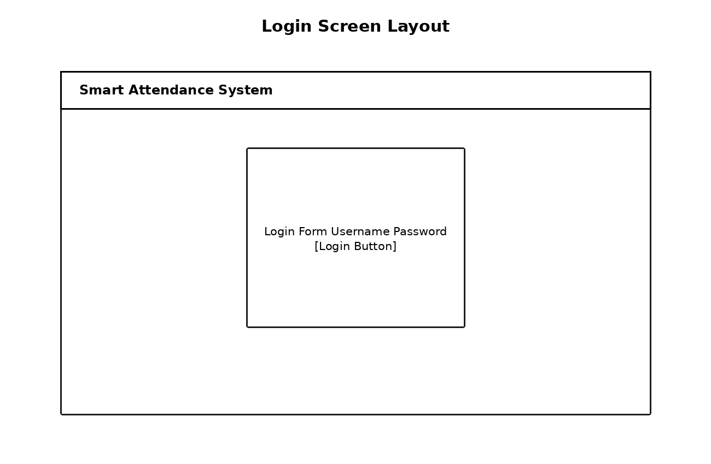
Figure 14: Login Screen Layout

Dashboard Screen Layout
In the context of dashboard screen layout, the main attention was given to making the feature easy to use and easy to understand. The project is an academic prototype, so the design avoids unnecessary complexity and keeps the working steps visible to the user.
The dashboard screen layout part also supports the overall aim of reducing manual work. Instead of depending on paper registers, the application stores information in a database and allows the record to be viewed later from the report screen.
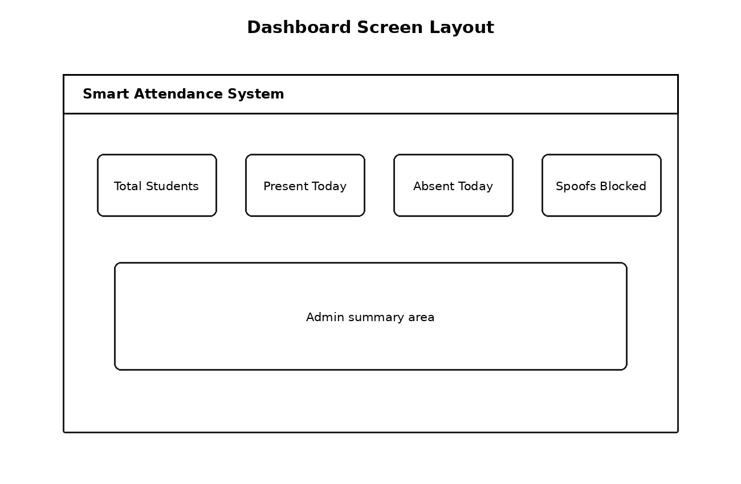
Figure 15: Dashboard Screen Layout

Student Management Screen Layout
In the context of student management screen layout, the main attention was given to making the feature easy to use and easy to understand. The project is an academic prototype, so the design avoids unnecessary complexity and keeps the working steps visible to the user.
The student management screen layout part also supports the overall aim of reducing manual work. Instead of depending on paper registers, the application stores information in a database and allows the record to be viewed later from the report screen.
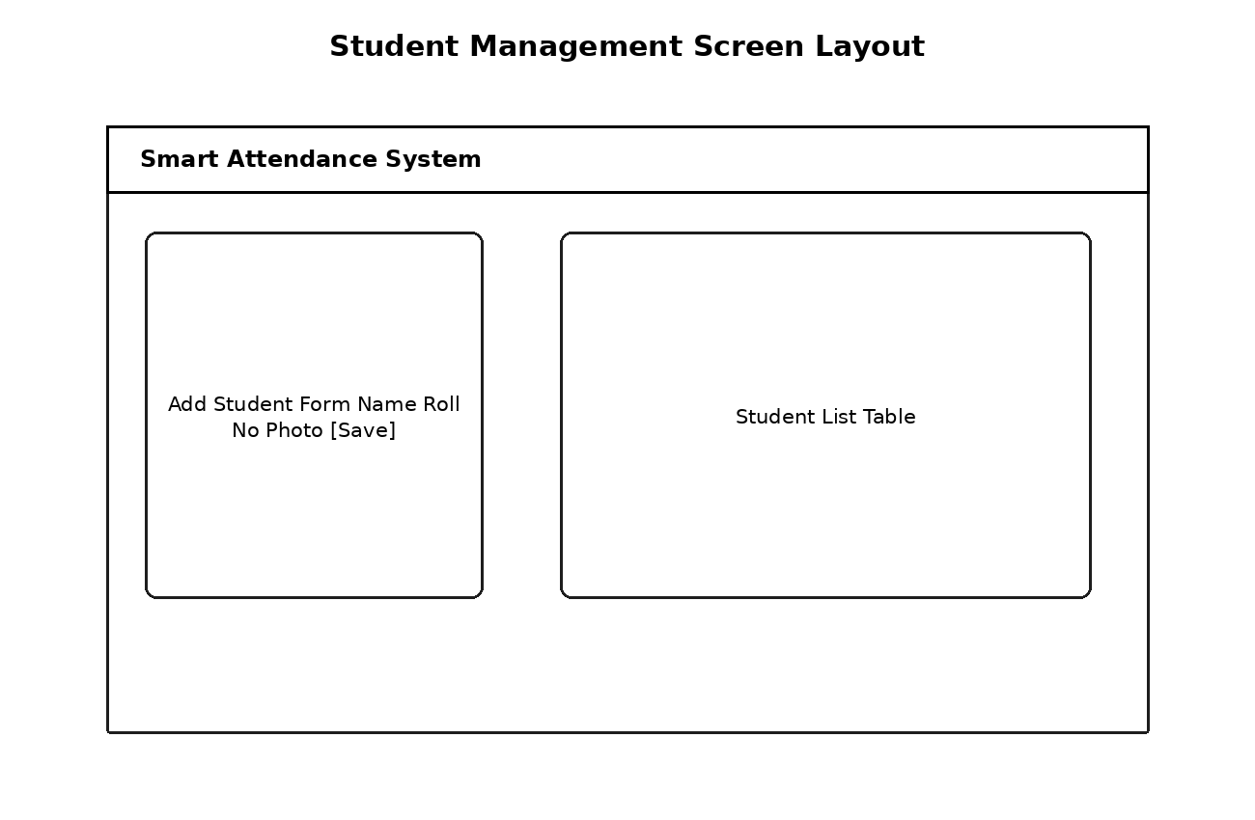
Figure 16: Student Management Screen Layout

Attendance Screen Layout
In the context of attendance screen layout, the main attention was given to making the feature easy to use and easy to understand. The project is an academic prototype, so the design avoids unnecessary complexity and keeps the working steps visible to the user.
The attendance screen layout part also supports the overall aim of reducing manual work. Instead of depending on paper registers, the application stores information in a database and allows the record to be viewed later from the report screen.
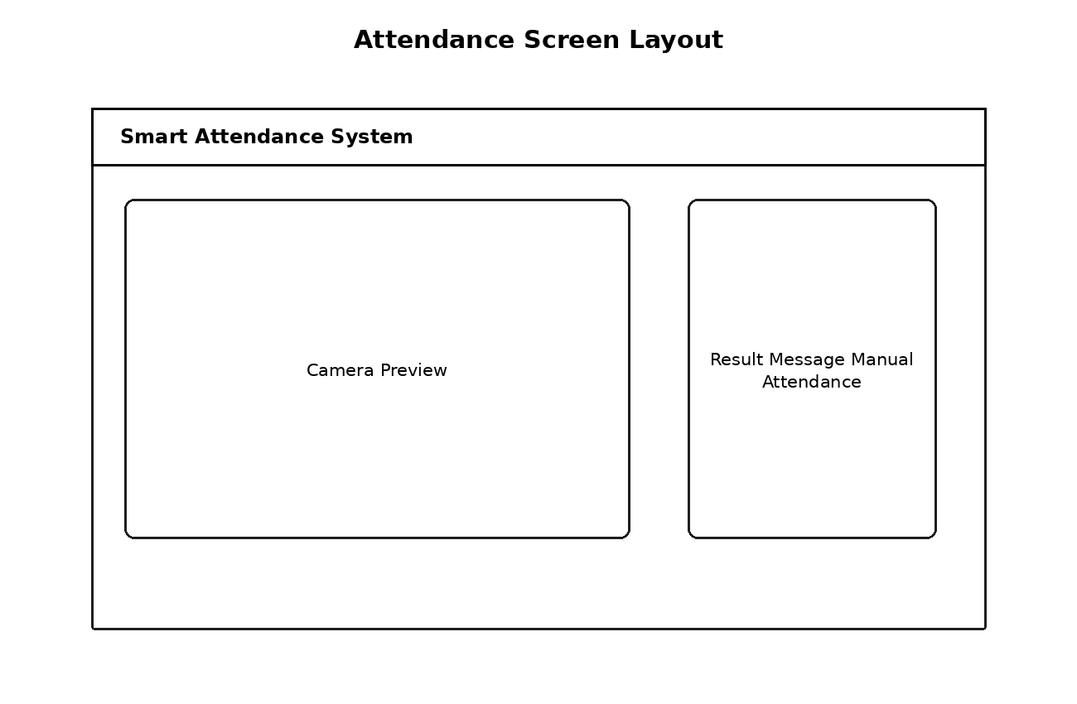
Figure 17: Attendance Screen Layout

Reports Screen Layout
In the context of reports screen layout, the main attention was given to making the feature easy to use and easy to understand. The project is an academic prototype, so the design avoids unnecessary complexity and keeps the working steps visible to the user.
The reports screen layout part also supports the overall aim of reducing manual work. Instead of depending on paper registers, the application stores information in a database and allows the record to be viewed later from the report screen.
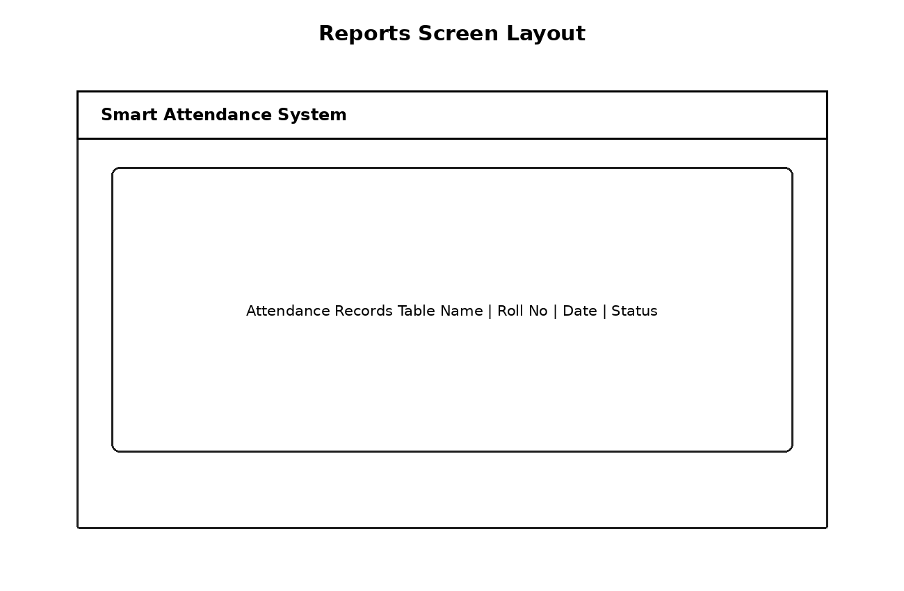
Figure 18: Reports Screen Layout

7.6 Real Admin and Student Screenshots
The following screenshots are taken from the actual Smart Attendance project. The admin dashboard shows total students, present students, absent students and spoof blocked count. The attendance page is visible in both admin and student modes. The student view is restricted compared with the admin view.
Including real screenshots is important because it shows the working interface and not only diagrams. These screenshots can also be used in the final presentation and viva.
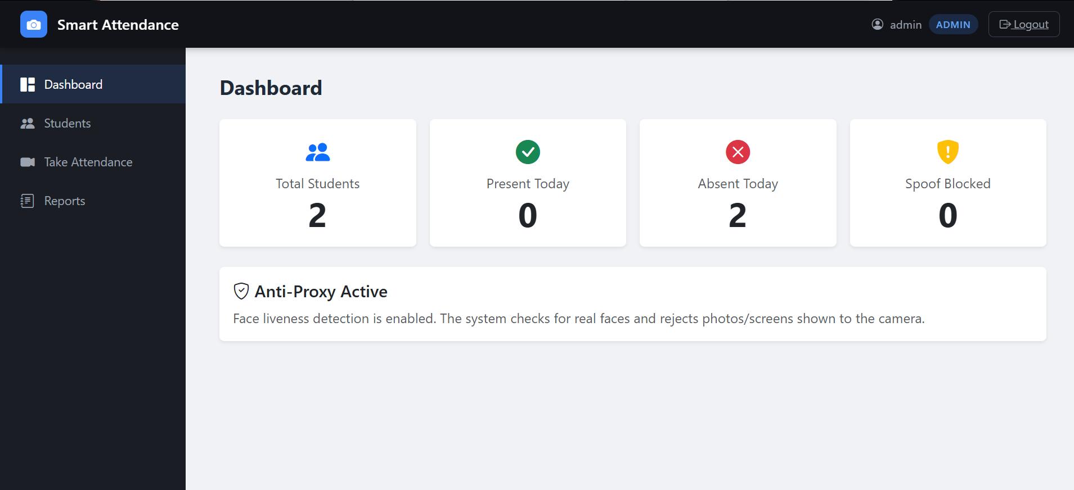
Real screenshot: Admin dashboard with total students, present today, absent today, and spoof blocked cards
In the context of admin dashboard with total students, present today, absent today, and spoof blocked cards, the main attention was given to making the feature easy to use and easy to understand. The project is an academic prototype, so the design avoids unnecessary complexity and keeps the working steps visible to the user.
The admin dashboard with total students, present today, absent today, and spoof blocked cards part also supports the overall aim of reducing manual work. Instead of depending on paper registers, the application stores information in a database and allows the record to be viewed later from the report screen.
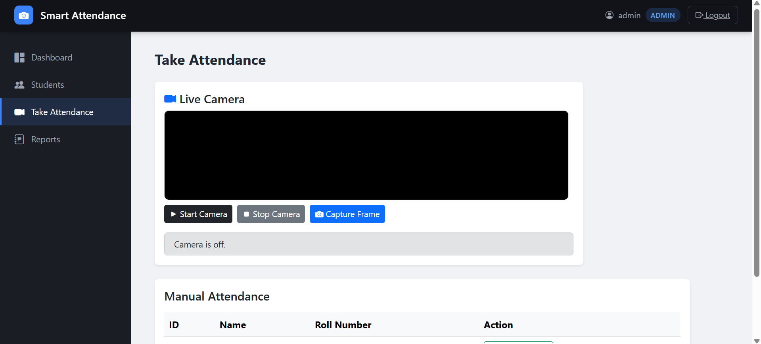
Real screenshot: Admin attendance page with live camera area and manual attendance table
In the context of admin attendance page with live camera area and manual attendance table, the main attention was given to making the feature easy to use and easy to understand. The project is an academic prototype, so the design avoids unnecessary complexity and keeps the working steps visible to the user.
The admin attendance page with live camera area and manual attendance table part also supports the overall aim of reducing manual work. Instead of depending on paper registers, the application stores information in a database and allows the record to be viewed later from the report screen.
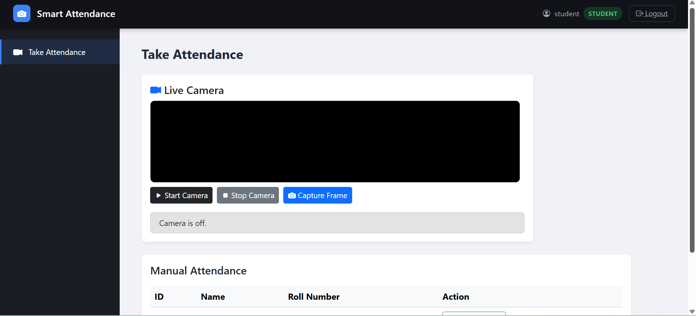
Real screenshot: Student attendance page with limited student access
In the context of student attendance page with limited student access, the main attention was given to making the feature easy to use and easy to understand. The project is an academic prototype, so the design avoids unnecessary complexity and keeps the working steps visible to the user.
The student attendance page with limited student access part also supports the overall aim of reducing manual work. Instead of depending on paper registers, the application stores information in a database and allows the record to be viewed later from the report screen.

7.7 UI Design Explanation
In the context of user interface design, the main attention was given to making the feature easy to use and easy to understand. The project is an academic prototype, so the design avoids unnecessary complexity and keeps the working steps visible to the user.
The user interface design part also supports the overall aim of reducing manual work. Instead of depending on paper registers, the application stores information in a database and allows the record to be viewed later from the report screen.
During development, the user interface design section was tested several times by opening the application in the browser and checking the result after every small change. This simple testing method helped in finding route errors, template path errors and database query mistakes.
The user interface design design is connected with other parts of the project. For example, the attendance page depends on registered students, saved face images, the camera capture process, the liveness check and the database insert query.
The final form of the user interface design module is suitable for demonstration because it shows a clear input, processing and output flow. The evaluator can see what data is entered, where it goes and how the result is shown.
If the project is improved in future, the user interface design module can be extended without changing the full system. The current design keeps the module separate enough that future improvements can be added step by step.
In the context of user interface design, the main attention was given to making the feature easy to use and easy to understand. The project is an academic prototype, so the design avoids unnecessary complexity and keeps the working steps visible to the user.
The user interface design part also supports the overall aim of reducing manual work. Instead of depending on paper registers, the application stores information in a database and allows the record to be viewed later from the report screen.
During development, the user interface design section was tested several times by opening the application in the browser and checking the result after every small change. This simple testing method helped in finding route errors, template path errors and database query mistakes.
The user interface design design is connected with other parts of the project. For example, the attendance page depends on registered students, saved face images, the camera capture process, the liveness check and the database insert query.
Template File Screen Main Use
Template File: base.html; Screen: Common layout; Main Use: Sidebar, topbar, role display and logout
Template File: login.html; Screen: Login screen; Main Use: Username and password form
Template File: dashboard.html; Screen: Dashboard; Main Use: Summary cards and anti-proxy message
Template File: add_student.html; Screen: Students; Main Use: Add and list students
Template File: attendance.html; Screen: Take Attendance; Main Use: Camera controls and manual attendance
Template File: records.html; Screen: Reports; Main Use: Attendance records table

CHAPTER 8 TESTING AND EVALUATION
Testing was performed after development to check whether the system behaves correctly. The project was tested page by page and feature by feature. The focus was on practical testing because the system is a final year project prototype.
The testing process included login testing, admin access testing, student access testing, student registration testing, attendance marking testing, duplicate attendance testing, report testing and database testing.
Test ID Feature Steps Expected Result Status
Test ID: TC-01; Feature: Admin login; Steps: Enter admin username and password; Expected Result: Dashboard opens; Status: Pass
Test ID: TC-02; Feature: Wrong login; Steps: Enter wrong password; Expected Result: Error message is shown; Status: Pass
Test ID: TC-03; Feature: Student login; Steps: Enter student credentials; Expected Result: Attendance page opens; Status: Pass
Test ID: TC-04; Feature: Admin guard; Steps: Open dashboard as student; Expected Result: Access denied or redirect; Status: Pass
Test ID: TC-05; Feature: Add student; Steps: Enter name, roll number and image; Expected Result: Student appears in list; Status: Pass
Test ID: TC-06; Feature: Delete student; Steps: Click delete for a student; Expected Result: Student and related attendance records are removed; Status: Pass
Test ID: TC-07; Feature: Start camera; Steps: Click start camera button; Expected Result: Browser camera preview starts; Status: Pass
Test ID: TC-08; Feature: Stop camera; Steps: Click stop camera button; Expected Result: Camera preview stops; Status: Pass
Test ID: TC-09; Feature: Capture frame; Steps: Click capture frame; Expected Result: Image is sent to backend; Status: Pass
Test ID: TC-10; Feature: No face test; Steps: Capture blank frame; Expected Result: No face message is shown; Status: Pass
Test ID: TC-11; Feature: Registered face; Steps: Capture registered face; Expected Result: Attendance is marked present; Status: Pass
Test ID: TC-12; Feature: Unknown face; Steps: Capture unregistered face; Expected Result: Unknown face message is shown; Status: Pass
Test ID: TC-13; Feature: Duplicate attendance; Steps: Mark same student again today; Expected Result: Duplicate record is not inserted; Status: Pass
Test ID: TC-14; Feature: Report page; Steps: Open reports as admin; Expected Result: Attendance rows are shown; Status: Pass
Test ID: TC-15; Feature: Dashboard counts; Steps: Mark present and open dashboard; Expected Result: Present and absent numbers update; Status: Pass
Test ID: TC-16; Feature: Spoof case; Steps: Show photo/screen to camera; Expected Result: Spoof warning may be shown; Status: Pass
Test ID: TC-17; Feature: Database file; Steps: Open attendance.db; Expected Result: Tables are present; Status: Pass
Test ID: TC-18; Feature: Template path; Steps: Open each page; Expected Result: Template renders correctly; Status: Pass
Test ID: TC-19; Feature: Logout; Steps: Click logout; Expected Result: User returns to login page; Status: Pass
Test ID: TC-20; Feature: Uploads folder; Steps: Add image or capture frame; Expected Result: File appears in uploads; Status: Pass

8.1 Testing Strategy
In the context of testing strategy, the main attention was given to making the feature easy to use and easy to understand. The project is an academic prototype, so the design avoids unnecessary complexity and keeps the working steps visible to the user.
The testing strategy part also supports the overall aim of reducing manual work. Instead of depending on paper registers, the application stores information in a database and allows the record to be viewed later from the report screen.
During development, the testing strategy section was tested several times by opening the application in the browser and checking the result after every small change. This simple testing method helped in finding route errors, template path errors and database query mistakes.
The testing strategy design is connected with other parts of the project. For example, the attendance page depends on registered students, saved face images, the camera capture process, the liveness check and the database insert query.
The final form of the testing strategy module is suitable for demonstration because it shows a clear input, processing and output flow. The evaluator can see what data is entered, where it goes and how the result is shown.
If the project is improved in future, the testing strategy module can be extended without changing the full system. The current design keeps the module separate enough that future improvements can be added step by step.
In the context of testing strategy, the main attention was given to making the feature easy to use and easy to understand. The project is an academic prototype, so the design avoids unnecessary complexity and keeps the working steps visible to the user.
The testing strategy part also supports the overall aim of reducing manual work. Instead of depending on paper registers, the application stores information in a database and allows the record to be viewed later from the report screen.
During development, the testing strategy section was tested several times by opening the application in the browser and checking the result after every small change. This simple testing method helped in finding route errors, template path errors and database query mistakes.
The testing strategy design is connected with other parts of the project. For example, the attendance page depends on registered students, saved face images, the camera capture process, the liveness check and the database insert query.

8.2 Module Testing
In the context of module testing, the main attention was given to making the feature easy to use and easy to understand. The project is an academic prototype, so the design avoids unnecessary complexity and keeps the working steps visible to the user.
The module testing part also supports the overall aim of reducing manual work. Instead of depending on paper registers, the application stores information in a database and allows the record to be viewed later from the report screen.
During development, the module testing section was tested several times by opening the application in the browser and checking the result after every small change. This simple testing method helped in finding route errors, template path errors and database query mistakes.
The module testing design is connected with other parts of the project. For example, the attendance page depends on registered students, saved face images, the camera capture process, the liveness check and the database insert query.
The final form of the module testing module is suitable for demonstration because it shows a clear input, processing and output flow. The evaluator can see what data is entered, where it goes and how the result is shown.
If the project is improved in future, the module testing module can be extended without changing the full system. The current design keeps the module separate enough that future improvements can be added step by step.
In the context of module testing, the main attention was given to making the feature easy to use and easy to understand. The project is an academic prototype, so the design avoids unnecessary complexity and keeps the working steps visible to the user.
The module testing part also supports the overall aim of reducing manual work. Instead of depending on paper registers, the application stores information in a database and allows the record to be viewed later from the report screen.

8.3 Integration Testing
In the context of integration testing, the main attention was given to making the feature easy to use and easy to understand. The project is an academic prototype, so the design avoids unnecessary complexity and keeps the working steps visible to the user.
The integration testing part also supports the overall aim of reducing manual work. Instead of depending on paper registers, the application stores information in a database and allows the record to be viewed later from the report screen.
During development, the integration testing section was tested several times by opening the application in the browser and checking the result after every small change. This simple testing method helped in finding route errors, template path errors and database query mistakes.
The integration testing design is connected with other parts of the project. For example, the attendance page depends on registered students, saved face images, the camera capture process, the liveness check and the database insert query.
The final form of the integration testing module is suitable for demonstration because it shows a clear input, processing and output flow. The evaluator can see what data is entered, where it goes and how the result is shown.
If the project is improved in future, the integration testing module can be extended without changing the full system. The current design keeps the module separate enough that future improvements can be added step by step.
In the context of integration testing, the main attention was given to making the feature easy to use and easy to understand. The project is an academic prototype, so the design avoids unnecessary complexity and keeps the working steps visible to the user.
The integration testing part also supports the overall aim of reducing manual work. Instead of depending on paper registers, the application stores information in a database and allows the record to be viewed later from the report screen.

8.4 Errors Found During Testing
Error Type Reason Solution
Error Type: Template not found; Reason: Wrong templates folder path; Solution: Set Jinja2Templates directory to app/templates
Error Type: Camera not opening; Reason: Browser permission not granted; Solution: Allow camera permission in browser
Error Type: Model not found; Reason: ONNX files missing; Solution: Run download_models.py
Error Type: Database column error; Reason: Old database schema; Solution: Recreate or update attendance.db
Error Type: Image path error; Reason: Uploaded image not saved properly; Solution: Check uploads folder and file path
Error Type: Access issue; Reason: Student opened admin route; Solution: Use require_admin guard

8.5 Evaluation Summary
In the context of evaluation summary, the main attention was given to making the feature easy to use and easy to understand. The project is an academic prototype, so the design avoids unnecessary complexity and keeps the working steps visible to the user.
The evaluation summary part also supports the overall aim of reducing manual work. Instead of depending on paper registers, the application stores information in a database and allows the record to be viewed later from the report screen.
During development, the evaluation summary section was tested several times by opening the application in the browser and checking the result after every small change. This simple testing method helped in finding route errors, template path errors and database query mistakes.
The evaluation summary design is connected with other parts of the project. For example, the attendance page depends on registered students, saved face images, the camera capture process, the liveness check and the database insert query.
The final form of the evaluation summary module is suitable for demonstration because it shows a clear input, processing and output flow. The evaluator can see what data is entered, where it goes and how the result is shown.
If the project is improved in future, the evaluation summary module can be extended without changing the full system. The current design keeps the module separate enough that future improvements can be added step by step.
In the context of evaluation summary, the main attention was given to making the feature easy to use and easy to understand. The project is an academic prototype, so the design avoids unnecessary complexity and keeps the working steps visible to the user.
The evaluation summary part also supports the overall aim of reducing manual work. Instead of depending on paper registers, the application stores information in a database and allows the record to be viewed later from the report screen.

CHAPTER 9 USER MANUAL AND DEPLOYMENT
This chapter explains how to run and use the system. The steps are written in simple wording so that another student can run the project on a laptop without confusion.
The system is intended to run locally in the development environment. Internet is only required if the required Python packages or model files need to be downloaded.

9.1 Installation Steps
- Open the project folder in Visual Studio Code.
- Create or activate the Python virtual environment.
- Install packages using pip install -r requirements.txt.
- Run download_models.py if the model files are not available.
- Start the server using uvicorn app.main:app --reload.
- Open the local address shown in the terminal.
- Login using the default admin or student account.
- Add students from the admin side and then test attendance.

9.2 Admin User Manual
In the context of admin user manual, the main attention was given to making the feature easy to use and easy to understand. The project is an academic prototype, so the design avoids unnecessary complexity and keeps the working steps visible to the user.
The admin user manual part also supports the overall aim of reducing manual work. Instead of depending on paper registers, the application stores information in a database and allows the record to be viewed later from the report screen.
During development, the admin user manual section was tested several times by opening the application in the browser and checking the result after every small change. This simple testing method helped in finding route errors, template path errors and database query mistakes.
The admin user manual design is connected with other parts of the project. For example, the attendance page depends on registered students, saved face images, the camera capture process, the liveness check and the database insert query.
The final form of the admin user manual module is suitable for demonstration because it shows a clear input, processing and output flow. The evaluator can see what data is entered, where it goes and how the result is shown.
If the project is improved in future, the admin user manual module can be extended without changing the full system. The current design keeps the module separate enough that future improvements can be added step by step.
In the context of admin user manual, the main attention was given to making the feature easy to use and easy to understand. The project is an academic prototype, so the design avoids unnecessary complexity and keeps the working steps visible to the user.
The admin user manual part also supports the overall aim of reducing manual work. Instead of depending on paper registers, the application stores information in a database and allows the record to be viewed later from the report screen.

9.3 Student User Manual
In the context of student user manual, the main attention was given to making the feature easy to use and easy to understand. The project is an academic prototype, so the design avoids unnecessary complexity and keeps the working steps visible to the user.
The student user manual part also supports the overall aim of reducing manual work. Instead of depending on paper registers, the application stores information in a database and allows the record to be viewed later from the report screen.
During development, the student user manual section was tested several times by opening the application in the browser and checking the result after every small change. This simple testing method helped in finding route errors, template path errors and database query mistakes.
The student user manual design is connected with other parts of the project. For example, the attendance page depends on registered students, saved face images, the camera capture process, the liveness check and the database insert query.
The final form of the student user manual module is suitable for demonstration because it shows a clear input, processing and output flow. The evaluator can see what data is entered, where it goes and how the result is shown.
If the project is improved in future, the student user manual module can be extended without changing the full system. The current design keeps the module separate enough that future improvements can be added step by step.
In the context of student user manual, the main attention was given to making the feature easy to use and easy to understand. The project is an academic prototype, so the design avoids unnecessary complexity and keeps the working steps visible to the user.
The student user manual part also supports the overall aim of reducing manual work. Instead of depending on paper registers, the application stores information in a database and allows the record to be viewed later from the report screen.

9.4 Operating Guidelines
- Use a clear face image when registering a student.
- Use good lighting when taking attendance.
- Keep the camera at face level for better recognition.
- Do not move too much while capturing the frame.
- Avoid using very blurry photos for registration.
- Keep the models folder and uploads folder in the correct place.
- Do not delete attendance.db unless the database needs to be recreated.

9.5 Deployment Notes
In the context of deployment notes, the main attention was given to making the feature easy to use and easy to understand. The project is an academic prototype, so the design avoids unnecessary complexity and keeps the working steps visible to the user.
The deployment notes part also supports the overall aim of reducing manual work. Instead of depending on paper registers, the application stores information in a database and allows the record to be viewed later from the report screen.
During development, the deployment notes section was tested several times by opening the application in the browser and checking the result after every small change. This simple testing method helped in finding route errors, template path errors and database query mistakes.
The deployment notes design is connected with other parts of the project. For example, the attendance page depends on registered students, saved face images, the camera capture process, the liveness check and the database insert query.
The final form of the deployment notes module is suitable for demonstration because it shows a clear input, processing and output flow. The evaluator can see what data is entered, where it goes and how the result is shown.
If the project is improved in future, the deployment notes module can be extended without changing the full system. The current design keeps the module separate enough that future improvements can be added step by step.
In the context of deployment notes, the main attention was given to making the feature easy to use and easy to understand. The project is an academic prototype, so the design avoids unnecessary complexity and keeps the working steps visible to the user.
The deployment notes part also supports the overall aim of reducing manual work. Instead of depending on paper registers, the application stores information in a database and allows the record to be viewed later from the report screen.
During development, the deployment notes section was tested several times by opening the application in the browser and checking the result after every small change. This simple testing method helped in finding route errors, template path errors and database query mistakes.
The deployment notes design is connected with other parts of the project. For example, the attendance page depends on registered students, saved face images, the camera capture process, the liveness check and the database insert query.

CHAPTER 10 CONCLUSION AND FUTURE WORK
The Smart Attendance System Using Face Recognition successfully demonstrates a simple web based attendance solution. The project includes login, admin dashboard, student management, camera based attendance, liveness checks and attendance reports.
The system is suitable for final year project demonstration because the working flow is clear. The admin can add students, the user can take attendance, and the result is stored in SQLite. The design is simple and can be explained easily during viva.
The project also shows how Python, FastAPI, SQLite, Jinja2 and OpenCV can be combined in one application. It is not a full commercial biometric attendance product, but it is a complete academic prototype.

10.1 Achievements
- Web based attendance system was developed.
- Role based login was implemented.
- SQLite database tables were created and used.
- Student registration with face image was added.
- Camera capture route was implemented.
- Face recognition logic was connected with attendance marking.
- Basic liveness checks were added.
- Real UI screens were prepared for admin and student users.
- Reports page was added for viewing attendance records.

10.2 Limitations
In the context of limitations, the main attention was given to making the feature easy to use and easy to understand. The project is an academic prototype, so the design avoids unnecessary complexity and keeps the working steps visible to the user.
The limitations part also supports the overall aim of reducing manual work. Instead of depending on paper registers, the application stores information in a database and allows the record to be viewed later from the report screen.
During development, the limitations section was tested several times by opening the application in the browser and checking the result after every small change. This simple testing method helped in finding route errors, template path errors and database query mistakes.
The limitations design is connected with other parts of the project. For example, the attendance page depends on registered students, saved face images, the camera capture process, the liveness check and the database insert query.
The final form of the limitations module is suitable for demonstration because it shows a clear input, processing and output flow. The evaluator can see what data is entered, where it goes and how the result is shown.
If the project is improved in future, the limitations module can be extended without changing the full system. The current design keeps the module separate enough that future improvements can be added step by step.
In the context of limitations, the main attention was given to making the feature easy to use and easy to understand. The project is an academic prototype, so the design avoids unnecessary complexity and keeps the working steps visible to the user.

10.3 Future Enhancements
Enhancement Benefit
Enhancement: Store face embeddings; Benefit: Faster recognition for many students
Enhancement: Export reports to Excel or PDF; Benefit: Better record sharing
Enhancement: Improve liveness with trained model; Benefit: Stronger anti-spoofing
Enhancement: Online deployment; Benefit: Access from multiple computers
Enhancement: Email alerts; Benefit: Automatic notifications
Enhancement: Better user management; Benefit: More secure roles and password reset
Enhancement: Attendance charts; Benefit: Better dashboard analysis
Enhancement: Mobile responsive camera capture; Benefit: Easier use from phone

10.4 Final Remarks
In the context of final remarks, the main attention was given to making the feature easy to use and easy to understand. The project is an academic prototype, so the design avoids unnecessary complexity and keeps the working steps visible to the user.
The final remarks part also supports the overall aim of reducing manual work. Instead of depending on paper registers, the application stores information in a database and allows the record to be viewed later from the report screen.
During development, the final remarks section was tested several times by opening the application in the browser and checking the result after every small change. This simple testing method helped in finding route errors, template path errors and database query mistakes.
The final remarks design is connected with other parts of the project. For example, the attendance page depends on registered students, saved face images, the camera capture process, the liveness check and the database insert query.
The final form of the final remarks module is suitable for demonstration because it shows a clear input, processing and output flow. The evaluator can see what data is entered, where it goes and how the result is shown.
If the project is improved in future, the final remarks module can be extended without changing the full system. The current design keeps the module separate enough that future improvements can be added step by step.
In the context of final remarks, the main attention was given to making the feature easy to use and easy to understand. The project is an academic prototype, so the design avoids unnecessary complexity and keeps the working steps visible to the user.
The final remarks part also supports the overall aim of reducing manual work. Instead of depending on paper registers, the application stores information in a database and allows the record to be viewed later from the report screen.

APPENDIX A PROJECT FILE DESCRIPTION
File / Folder Description
File / Folder: app/main.py; Description: Creates FastAPI app and mounts routes and uploads
File / Folder: app/auth.py; Description: Contains session and role guard functions
File / Folder: app/routes/pages.py; Description: Contains page routes, form actions, camera capture and face recognition logic
File / Folder: app/templates/base.html; Description: Common layout for pages
File / Folder: app/templates/login.html; Description: Login form template
File / Folder: app/templates/dashboard.html; Description: Dashboard cards template
File / Folder: app/templates/add_student.html; Description: Student add/list page
File / Folder: app/templates/attendance.html; Description: Camera and manual attendance page
File / Folder: app/templates/records.html; Description: Attendance report page
File / Folder: database.py; Description: SQLite table and query helper functions
File / Folder: attendance.db; Description: Local SQLite database file
File / Folder: download_models.py; Description: Downloads OpenCV face models
File / Folder: requirements.txt; Description: Python dependencies
File / Folder: uploads; Description: Uploaded images and camera capture
File / Folder: models; Description: OpenCV model files

In the context of project file description, the main attention was given to making the feature easy to use and easy to understand. The project is an academic prototype, so the design avoids unnecessary complexity and keeps the working steps visible to the user.
The project file description part also supports the overall aim of reducing manual work. Instead of depending on paper registers, the application stores information in a database and allows the record to be viewed later from the report screen.
During development, the project file description section was tested several times by opening the application in the browser and checking the result after every small change. This simple testing method helped in finding route errors, template path errors and database query mistakes.
The project file description design is connected with other parts of the project. For example, the attendance page depends on registered students, saved face images, the camera capture process, the liveness check and the database insert query.
The final form of the project file description module is suitable for demonstration because it shows a clear input, processing and output flow. The evaluator can see what data is entered, where it goes and how the result is shown.
If the project is improved in future, the project file description module can be extended without changing the full system. The current design keeps the module separate enough that future improvements can be added step by step.
In the context of project file description, the main attention was given to making the feature easy to use and easy to understand. The project is an academic prototype, so the design avoids unnecessary complexity and keeps the working steps visible to the user.
The project file description part also supports the overall aim of reducing manual work. Instead of depending on paper registers, the application stores information in a database and allows the record to be viewed later from the report screen.

APPENDIX B VIVA PREPARATION NOTES
No. Question Answer
No.: Q1; Question: What is the main purpose of the project?; Answer: To mark attendance using face recognition instead of manual register marking.
No.: Q2; Question: Why was FastAPI selected?; Answer: It is simple, fast and good for creating Python web routes.
No.: Q3; Question: Why was SQLite selected?; Answer: It stores data in one local file and is easy for a final year project.
No.: Q4; Question: What is liveness detection?; Answer: It is a check to reduce fake attendance using photos or screens.
No.: Q5; Question: What does the admin do?; Answer: Admin manages students, views dashboard and checks reports.
No.: Q6; Question: What does the student do?; Answer: Student accesses the attendance page and marks attendance.
No.: Q7; Question: How duplicate attendance is avoided?; Answer: The database checks student_id and date before inserting a new row.
No.: Q8; Question: Where images are stored?; Answer: Images are stored in the uploads folder and paths are saved in database.
No.: Q9; Question: What are the main tables?; Answer: users, students and attendance.
No.: Q10; Question: What is future work?; Answer: Better liveness model, report export, online deployment and stored embeddings.

In the context of viva preparation, the main attention was given to making the feature easy to use and easy to understand. The project is an academic prototype, so the design avoids unnecessary complexity and keeps the working steps visible to the user.
The viva preparation part also supports the overall aim of reducing manual work. Instead of depending on paper registers, the application stores information in a database and allows the record to be viewed later from the report screen.
During development, the viva preparation section was tested several times by opening the application in the browser and checking the result after every small change. This simple testing method helped in finding route errors, template path errors and database query mistakes.
The viva preparation design is connected with other parts of the project. For example, the attendance page depends on registered students, saved face images, the camera capture process, the liveness check and the database insert query.
The final form of the viva preparation module is suitable for demonstration because it shows a clear input, processing and output flow. The evaluator can see what data is entered, where it goes and how the result is shown.
If the project is improved in future, the viva preparation module can be extended without changing the full system. The current design keeps the module separate enough that future improvements can be added step by step.
In the context of viva preparation, the main attention was given to making the feature easy to use and easy to understand. The project is an academic prototype, so the design avoids unnecessary complexity and keeps the working steps visible to the user.
The viva preparation part also supports the overall aim of reducing manual work. Instead of depending on paper registers, the application stores information in a database and allows the record to be viewed later from the report screen.
During development, the viva preparation section was tested several times by opening the application in the browser and checking the result after every small change. This simple testing method helped in finding route errors, template path errors and database query mistakes.
The viva preparation design is connected with other parts of the project. For example, the attendance page depends on registered students, saved face images, the camera capture process, the liveness check and the database insert query.

APPENDIX C EXTENDED PROJECT NOTES

Camera Handling
In the context of camera handling, the main attention was given to making the feature easy to use and easy to understand. The project is an academic prototype, so the design avoids unnecessary complexity and keeps the working steps visible to the user.
The camera handling part also supports the overall aim of reducing manual work. Instead of depending on paper registers, the application stores information in a database and allows the record to be viewed later from the report screen.
During development, the camera handling section was tested several times by opening the application in the browser and checking the result after every small change. This simple testing method helped in finding route errors, template path errors and database query mistakes.
The camera handling design is connected with other parts of the project. For example, the attendance page depends on registered students, saved face images, the camera capture process, the liveness check and the database insert query.
The final form of the camera handling module is suitable for demonstration because it shows a clear input, processing and output flow. The evaluator can see what data is entered, where it goes and how the result is shown.

Attendance Record Management
In the context of attendance record management, the main attention was given to making the feature easy to use and easy to understand. The project is an academic prototype, so the design avoids unnecessary complexity and keeps the working steps visible to the user.
The attendance record management part also supports the overall aim of reducing manual work. Instead of depending on paper registers, the application stores information in a database and allows the record to be viewed later from the report screen.
During development, the attendance record management section was tested several times by opening the application in the browser and checking the result after every small change. This simple testing method helped in finding route errors, template path errors and database query mistakes.
The attendance record management design is connected with other parts of the project. For example, the attendance page depends on registered students, saved face images, the camera capture process, the liveness check and the database insert query.
The final form of the attendance record management module is suitable for demonstration because it shows a clear input, processing and output flow. The evaluator can see what data is entered, where it goes and how the result is shown.

Student Registration
In the context of student registration, the main attention was given to making the feature easy to use and easy to understand. The project is an academic prototype, so the design avoids unnecessary complexity and keeps the working steps visible to the user.
The student registration part also supports the overall aim of reducing manual work. Instead of depending on paper registers, the application stores information in a database and allows the record to be viewed later from the report screen.
During development, the student registration section was tested several times by opening the application in the browser and checking the result after every small change. This simple testing method helped in finding route errors, template path errors and database query mistakes.
The student registration design is connected with other parts of the project. For example, the attendance page depends on registered students, saved face images, the camera capture process, the liveness check and the database insert query.
The final form of the student registration module is suitable for demonstration because it shows a clear input, processing and output flow. The evaluator can see what data is entered, where it goes and how the result is shown.

Security Improvement
In the context of security improvement, the main attention was given to making the feature easy to use and easy to understand. The project is an academic prototype, so the design avoids unnecessary complexity and keeps the working steps visible to the user.
The security improvement part also supports the overall aim of reducing manual work. Instead of depending on paper registers, the application stores information in a database and allows the record to be viewed later from the report screen.
During development, the security improvement section was tested several times by opening the application in the browser and checking the result after every small change. This simple testing method helped in finding route errors, template path errors and database query mistakes.
The security improvement design is connected with other parts of the project. For example, the attendance page depends on registered students, saved face images, the camera capture process, the liveness check and the database insert query.
The final form of the security improvement module is suitable for demonstration because it shows a clear input, processing and output flow. The evaluator can see what data is entered, where it goes and how the result is shown.

Database Backup
In the context of database backup, the main attention was given to making the feature easy to use and easy to understand. The project is an academic prototype, so the design avoids unnecessary complexity and keeps the working steps visible to the user.
The database backup part also supports the overall aim of reducing manual work. Instead of depending on paper registers, the application stores information in a database and allows the record to be viewed later from the report screen.
During development, the database backup section was tested several times by opening the application in the browser and checking the result after every small change. This simple testing method helped in finding route errors, template path errors and database query mistakes.
The database backup design is connected with other parts of the project. For example, the attendance page depends on registered students, saved face images, the camera capture process, the liveness check and the database insert query.
The final form of the database backup module is suitable for demonstration because it shows a clear input, processing and output flow. The evaluator can see what data is entered, where it goes and how the result is shown.

Report Checking
In the context of report checking, the main attention was given to making the feature easy to use and easy to understand. The project is an academic prototype, so the design avoids unnecessary complexity and keeps the working steps visible to the user.
The report checking part also supports the overall aim of reducing manual work. Instead of depending on paper registers, the application stores information in a database and allows the record to be viewed later from the report screen.
During development, the report checking section was tested several times by opening the application in the browser and checking the result after every small change. This simple testing method helped in finding route errors, template path errors and database query mistakes.
The report checking design is connected with other parts of the project. For example, the attendance page depends on registered students, saved face images, the camera capture process, the liveness check and the database insert query.
The final form of the report checking module is suitable for demonstration because it shows a clear input, processing and output flow. The evaluator can see what data is entered, where it goes and how the result is shown.

Project Demonstration
In the context of project demonstration, the main attention was given to making the feature easy to use and easy to understand. The project is an academic prototype, so the design avoids unnecessary complexity and keeps the working steps visible to the user.
The project demonstration part also supports the overall aim of reducing manual work. Instead of depending on paper registers, the application stores information in a database and allows the record to be viewed later from the report screen.
During development, the project demonstration section was tested several times by opening the application in the browser and checking the result after every small change. This simple testing method helped in finding route errors, template path errors and database query mistakes.
The project demonstration design is connected with other parts of the project. For example, the attendance page depends on registered students, saved face images, the camera capture process, the liveness check and the database insert query.
The final form of the project demonstration module is suitable for demonstration because it shows a clear input, processing and output flow. The evaluator can see what data is entered, where it goes and how the result is shown.

Error Handling
In the context of error handling, the main attention was given to making the feature easy to use and easy to understand. The project is an academic prototype, so the design avoids unnecessary complexity and keeps the working steps visible to the user.
The error handling part also supports the overall aim of reducing manual work. Instead of depending on paper registers, the application stores information in a database and allows the record to be viewed later from the report screen.
During development, the error handling section was tested several times by opening the application in the browser and checking the result after every small change. This simple testing method helped in finding route errors, template path errors and database query mistakes.
The error handling design is connected with other parts of the project. For example, the attendance page depends on registered students, saved face images, the camera capture process, the liveness check and the database insert query.
The final form of the error handling module is suitable for demonstration because it shows a clear input, processing and output flow. The evaluator can see what data is entered, where it goes and how the result is shown.

Maintenance
In the context of maintenance, the main attention was given to making the feature easy to use and easy to understand. The project is an academic prototype, so the design avoids unnecessary complexity and keeps the working steps visible to the user.
The maintenance part also supports the overall aim of reducing manual work. Instead of depending on paper registers, the application stores information in a database and allows the record to be viewed later from the report screen.
During development, the maintenance section was tested several times by opening the application in the browser and checking the result after every small change. This simple testing method helped in finding route errors, template path errors and database query mistakes.
The maintenance design is connected with other parts of the project. For example, the attendance page depends on registered students, saved face images, the camera capture process, the liveness check and the database insert query.
The final form of the maintenance module is suitable for demonstration because it shows a clear input, processing and output flow. The evaluator can see what data is entered, where it goes and how the result is shown.

Future Classroom Use
In the context of future classroom use, the main attention was given to making the feature easy to use and easy to understand. The project is an academic prototype, so the design avoids unnecessary complexity and keeps the working steps visible to the user.
The future classroom use part also supports the overall aim of reducing manual work. Instead of depending on paper registers, the application stores information in a database and allows the record to be viewed later from the report screen.
During development, the future classroom use section was tested several times by opening the application in the browser and checking the result after every small change. This simple testing method helped in finding route errors, template path errors and database query mistakes.
The future classroom use design is connected with other parts of the project. For example, the attendance page depends on registered students, saved face images, the camera capture process, the liveness check and the database insert query.
The final form of the future classroom use module is suitable for demonstration because it shows a clear input, processing and output flow. The evaluator can see what data is entered, where it goes and how the result is shown.

Software Quality
In the context of software quality, the main attention was given to making the feature easy to use and easy to understand. The project is an academic prototype, so the design avoids unnecessary complexity and keeps the working steps visible to the user.
The software quality part also supports the overall aim of reducing manual work. Instead of depending on paper registers, the application stores information in a database and allows the record to be viewed later from the report screen.
During development, the software quality section was tested several times by opening the application in the browser and checking the result after every small change. This simple testing method helped in finding route errors, template path errors and database query mistakes.
The software quality design is connected with other parts of the project. For example, the attendance page depends on registered students, saved face images, the camera capture process, the liveness check and the database insert query.
The final form of the software quality module is suitable for demonstration because it shows a clear input, processing and output flow. The evaluator can see what data is entered, where it goes and how the result is shown.

Teacher Workflow
In the context of teacher workflow, the main attention was given to making the feature easy to use and easy to understand. The project is an academic prototype, so the design avoids unnecessary complexity and keeps the working steps visible to the user.
The teacher workflow part also supports the overall aim of reducing manual work. Instead of depending on paper registers, the application stores information in a database and allows the record to be viewed later from the report screen.
During development, the teacher workflow section was tested several times by opening the application in the browser and checking the result after every small change. This simple testing method helped in finding route errors, template path errors and database query mistakes.
The teacher workflow design is connected with other parts of the project. For example, the attendance page depends on registered students, saved face images, the camera capture process, the liveness check and the database insert query.
The final form of the teacher workflow module is suitable for demonstration because it shows a clear input, processing and output flow. The evaluator can see what data is entered, where it goes and how the result is shown.

APPENDIX D DETAILED MODULE EXPLANATION

Login Module
The login module part of the Smart Attendance project was written with a practical final year project approach. The aim was not to make a very complex commercial system, but to build a clear working prototype that can be demonstrated in front of the supervisor and external evaluator. Every important step is visible in the interface, so the user can understand what is happening when data is entered, when a picture is captured, and when attendance is stored.
While working on login module, the project files were kept simple and separated. This helped in debugging because the developer could open one file, check one responsibility, and then test the result in the browser. For example, the template files are responsible for layout, the route file is responsible for page actions, and the database file is responsible for insert and select queries. This separation also makes the documentation easier to read.
A good point about the login module module is that it supports the complete attendance workflow. The system starts with login, moves to student data or attendance capture, processes the request in the backend, and then stores or displays the result. Because each part is connected with the next part, testing was performed carefully after every change. The browser was refreshed, the action was repeated, and the database result was checked.
There are also some limitations in the current login module implementation. The project is mainly designed for local use and demonstration. If the same system is used in a large institution, it will need more secure sessions, better user management, a stronger face model, backup management and report export. These limitations do not reduce the academic value of the project because the main concept is working and understandable.
During viva, the login module section can be explained by starting from the user action and ending at the database result. This style of explanation is easy for evaluators because it follows the same order in which the application works. The student can also show the related page, route, database table and screenshot to prove that the feature is implemented.
Future work for login module can be added gradually. The current structure allows new features to be added without rewriting the whole project. For example, report export can be added to the records page, better face embeddings can be saved in the database, and the admin can be given additional controls for class sections, dates and attendance summaries.

Dashboard Module
The dashboard module part of the Smart Attendance project was written with a practical final year project approach. The aim was not to make a very complex commercial system, but to build a clear working prototype that can be demonstrated in front of the supervisor and external evaluator. Every important step is visible in the interface, so the user can understand what is happening when data is entered, when a picture is captured, and when attendance is stored.
While working on dashboard module, the project files were kept simple and separated. This helped in debugging because the developer could open one file, check one responsibility, and then test the result in the browser. For example, the template files are responsible for layout, the route file is responsible for page actions, and the database file is responsible for insert and select queries. This separation also makes the documentation easier to read.
A good point about the dashboard module module is that it supports the complete attendance workflow. The system starts with login, moves to student data or attendance capture, processes the request in the backend, and then stores or displays the result. Because each part is connected with the next part, testing was performed carefully after every change. The browser was refreshed, the action was repeated, and the database result was checked.
There are also some limitations in the current dashboard module implementation. The project is mainly designed for local use and demonstration. If the same system is used in a large institution, it will need more secure sessions, better user management, a stronger face model, backup management and report export. These limitations do not reduce the academic value of the project because the main concept is working and understandable.
During viva, the dashboard module section can be explained by starting from the user action and ending at the database result. This style of explanation is easy for evaluators because it follows the same order in which the application works. The student can also show the related page, route, database table and screenshot to prove that the feature is implemented.
Future work for dashboard module can be added gradually. The current structure allows new features to be added without rewriting the whole project. For example, report export can be added to the records page, better face embeddings can be saved in the database, and the admin can be given additional controls for class sections, dates and attendance summaries.

Student Management Module
The student management module part of the Smart Attendance project was written with a practical final year project approach. The aim was not to make a very complex commercial system, but to build a clear working prototype that can be demonstrated in front of the supervisor and external evaluator. Every important step is visible in the interface, so the user can understand what is happening when data is entered, when a picture is captured, and when attendance is stored.
While working on student management module, the project files were kept simple and separated. This helped in debugging because the developer could open one file, check one responsibility, and then test the result in the browser. For example, the template files are responsible for layout, the route file is responsible for page actions, and the database file is responsible for insert and select queries. This separation also makes the documentation easier to read.
A good point about the student management module module is that it supports the complete attendance workflow. The system starts with login, moves to student data or attendance capture, processes the request in the backend, and then stores or displays the result. Because each part is connected with the next part, testing was performed carefully after every change. The browser was refreshed, the action was repeated, and the database result was checked.
There are also some limitations in the current student management module implementation. The project is mainly designed for local use and demonstration. If the same system is used in a large institution, it will need more secure sessions, better user management, a stronger face model, backup management and report export. These limitations do not reduce the academic value of the project because the main concept is working and understandable.
During viva, the student management module section can be explained by starting from the user action and ending at the database result. This style of explanation is easy for evaluators because it follows the same order in which the application works. The student can also show the related page, route, database table and screenshot to prove that the feature is implemented.
Future work for student management module can be added gradually. The current structure allows new features to be added without rewriting the whole project. For example, report export can be added to the records page, better face embeddings can be saved in the database, and the admin can be given additional controls for class sections, dates and attendance summaries.

Attendance Module
The attendance module part of the Smart Attendance project was written with a practical final year project approach. The aim was not to make a very complex commercial system, but to build a clear working prototype that can be demonstrated in front of the supervisor and external evaluator. Every important step is visible in the interface, so the user can understand what is happening when data is entered, when a picture is captured, and when attendance is stored.
While working on attendance module, the project files were kept simple and separated. This helped in debugging because the developer could open one file, check one responsibility, and then test the result in the browser. For example, the template files are responsible for layout, the route file is responsible for page actions, and the database file is responsible for insert and select queries. This separation also makes the documentation easier to read.
A good point about the attendance module module is that it supports the complete attendance workflow. The system starts with login, moves to student data or attendance capture, processes the request in the backend, and then stores or displays the result. Because each part is connected with the next part, testing was performed carefully after every change. The browser was refreshed, the action was repeated, and the database result was checked.
There are also some limitations in the current attendance module implementation. The project is mainly designed for local use and demonstration. If the same system is used in a large institution, it will need more secure sessions, better user management, a stronger face model, backup management and report export. These limitations do not reduce the academic value of the project because the main concept is working and understandable.
During viva, the attendance module section can be explained by starting from the user action and ending at the database result. This style of explanation is easy for evaluators because it follows the same order in which the application works. The student can also show the related page, route, database table and screenshot to prove that the feature is implemented.
Future work for attendance module can be added gradually. The current structure allows new features to be added without rewriting the whole project. For example, report export can be added to the records page, better face embeddings can be saved in the database, and the admin can be given additional controls for class sections, dates and attendance summaries.

Report Module
The report module part of the Smart Attendance project was written with a practical final year project approach. The aim was not to make a very complex commercial system, but to build a clear working prototype that can be demonstrated in front of the supervisor and external evaluator. Every important step is visible in the interface, so the user can understand what is happening when data is entered, when a picture is captured, and when attendance is stored.
While working on report module, the project files were kept simple and separated. This helped in debugging because the developer could open one file, check one responsibility, and then test the result in the browser. For example, the template files are responsible for layout, the route file is responsible for page actions, and the database file is responsible for insert and select queries. This separation also makes the documentation easier to read.
A good point about the report module module is that it supports the complete attendance workflow. The system starts with login, moves to student data or attendance capture, processes the request in the backend, and then stores or displays the result. Because each part is connected with the next part, testing was performed carefully after every change. The browser was refreshed, the action was repeated, and the database result was checked.
There are also some limitations in the current report module implementation. The project is mainly designed for local use and demonstration. If the same system is used in a large institution, it will need more secure sessions, better user management, a stronger face model, backup management and report export. These limitations do not reduce the academic value of the project because the main concept is working and understandable.
During viva, the report module section can be explained by starting from the user action and ending at the database result. This style of explanation is easy for evaluators because it follows the same order in which the application works. The student can also show the related page, route, database table and screenshot to prove that the feature is implemented.
Future work for report module can be added gradually. The current structure allows new features to be added without rewriting the whole project. For example, report export can be added to the records page, better face embeddings can be saved in the database, and the admin can be given additional controls for class sections, dates and attendance summaries.

Liveness Module
The liveness module part of the Smart Attendance project was written with a practical final year project approach. The aim was not to make a very complex commercial system, but to build a clear working prototype that can be demonstrated in front of the supervisor and external evaluator. Every important step is visible in the interface, so the user can understand what is happening when data is entered, when a picture is captured, and when attendance is stored.
While working on liveness module, the project files were kept simple and separated. This helped in debugging because the developer could open one file, check one responsibility, and then test the result in the browser. For example, the template files are responsible for layout, the route file is responsible for page actions, and the database file is responsible for insert and select queries. This separation also makes the documentation easier to read.
A good point about the liveness module module is that it supports the complete attendance workflow. The system starts with login, moves to student data or attendance capture, processes the request in the backend, and then stores or displays the result. Because each part is connected with the next part, testing was performed carefully after every change. The browser was refreshed, the action was repeated, and the database result was checked.
There are also some limitations in the current liveness module implementation. The project is mainly designed for local use and demonstration. If the same system is used in a large institution, it will need more secure sessions, better user management, a stronger face model, backup management and report export. These limitations do not reduce the academic value of the project because the main concept is working and understandable.
During viva, the liveness module section can be explained by starting from the user action and ending at the database result. This style of explanation is easy for evaluators because it follows the same order in which the application works. The student can also show the related page, route, database table and screenshot to prove that the feature is implemented.
Future work for liveness module can be added gradually. The current structure allows new features to be added without rewriting the whole project. For example, report export can be added to the records page, better face embeddings can be saved in the database, and the admin can be given additional controls for class sections, dates and attendance summaries.

Face Comparison Module
The face comparison module part of the Smart Attendance project was written with a practical final year project approach. The aim was not to make a very complex commercial system, but to build a clear working prototype that can be demonstrated in front of the supervisor and external evaluator. Every important step is visible in the interface, so the user can understand what is happening when data is entered, when a picture is captured, and when attendance is stored.
While working on face comparison module, the project files were kept simple and separated. This helped in debugging because the developer could open one file, check one responsibility, and then test the result in the browser. For example, the template files are responsible for layout, the route file is responsible for page actions, and the database file is responsible for insert and select queries. This separation also makes the documentation easier to read.
A good point about the face comparison module module is that it supports the complete attendance workflow. The system starts with login, moves to student data or attendance capture, processes the request in the backend, and then stores or displays the result. Because each part is connected with the next part, testing was performed carefully after every change. The browser was refreshed, the action was repeated, and the database result was checked.
There are also some limitations in the current face comparison module implementation. The project is mainly designed for local use and demonstration. If the same system is used in a large institution, it will need more secure sessions, better user management, a stronger face model, backup management and report export. These limitations do not reduce the academic value of the project because the main concept is working and understandable.
During viva, the face comparison module section can be explained by starting from the user action and ending at the database result. This style of explanation is easy for evaluators because it follows the same order in which the application works. The student can also show the related page, route, database table and screenshot to prove that the feature is implemented.
Future work for face comparison module can be added gradually. The current structure allows new features to be added without rewriting the whole project. For example, report export can be added to the records page, better face embeddings can be saved in the database, and the admin can be given additional controls for class sections, dates and attendance summaries.

Database Module
The database module part of the Smart Attendance project was written with a practical final year project approach. The aim was not to make a very complex commercial system, but to build a clear working prototype that can be demonstrated in front of the supervisor and external evaluator. Every important step is visible in the interface, so the user can understand what is happening when data is entered, when a picture is captured, and when attendance is stored.
While working on database module, the project files were kept simple and separated. This helped in debugging because the developer could open one file, check one responsibility, and then test the result in the browser. For example, the template files are responsible for layout, the route file is responsible for page actions, and the database file is responsible for insert and select queries. This separation also makes the documentation easier to read.
A good point about the database module module is that it supports the complete attendance workflow. The system starts with login, moves to student data or attendance capture, processes the request in the backend, and then stores or displays the result. Because each part is connected with the next part, testing was performed carefully after every change. The browser was refreshed, the action was repeated, and the database result was checked.
There are also some limitations in the current database module implementation. The project is mainly designed for local use and demonstration. If the same system is used in a large institution, it will need more secure sessions, better user management, a stronger face model, backup management and report export. These limitations do not reduce the academic value of the project because the main concept is working and understandable.
During viva, the database module section can be explained by starting from the user action and ending at the database result. This style of explanation is easy for evaluators because it follows the same order in which the application works. The student can also show the related page, route, database table and screenshot to prove that the feature is implemented.
Future work for database module can be added gradually. The current structure allows new features to be added without rewriting the whole project. For example, report export can be added to the records page, better face embeddings can be saved in the database, and the admin can be given additional controls for class sections, dates and attendance summaries.

Template Module
The template module part of the Smart Attendance project was written with a practical final year project approach. The aim was not to make a very complex commercial system, but to build a clear working prototype that can be demonstrated in front of the supervisor and external evaluator. Every important step is visible in the interface, so the user can understand what is happening when data is entered, when a picture is captured, and when attendance is stored.
While working on template module, the project files were kept simple and separated. This helped in debugging because the developer could open one file, check one responsibility, and then test the result in the browser. For example, the template files are responsible for layout, the route file is responsible for page actions, and the database file is responsible for insert and select queries. This separation also makes the documentation easier to read.
A good point about the template module module is that it supports the complete attendance workflow. The system starts with login, moves to student data or attendance capture, processes the request in the backend, and then stores or displays the result. Because each part is connected with the next part, testing was performed carefully after every change. The browser was refreshed, the action was repeated, and the database result was checked.
There are also some limitations in the current template module implementation. The project is mainly designed for local use and demonstration. If the same system is used in a large institution, it will need more secure sessions, better user management, a stronger face model, backup management and report export. These limitations do not reduce the academic value of the project because the main concept is working and understandable.
During viva, the template module section can be explained by starting from the user action and ending at the database result. This style of explanation is easy for evaluators because it follows the same order in which the application works. The student can also show the related page, route, database table and screenshot to prove that the feature is implemented.
Future work for template module can be added gradually. The current structure allows new features to be added without rewriting the whole project. For example, report export can be added to the records page, better face embeddings can be saved in the database, and the admin can be given additional controls for class sections, dates and attendance summaries.

Route Module
The route module part of the Smart Attendance project was written with a practical final year project approach. The aim was not to make a very complex commercial system, but to build a clear working prototype that can be demonstrated in front of the supervisor and external evaluator. Every important step is visible in the interface, so the user can understand what is happening when data is entered, when a picture is captured, and when attendance is stored.
While working on route module, the project files were kept simple and separated. This helped in debugging because the developer could open one file, check one responsibility, and then test the result in the browser. For example, the template files are responsible for layout, the route file is responsible for page actions, and the database file is responsible for insert and select queries. This separation also makes the documentation easier to read.
A good point about the route module module is that it supports the complete attendance workflow. The system starts with login, moves to student data or attendance capture, processes the request in the backend, and then stores or displays the result. Because each part is connected with the next part, testing was performed carefully after every change. The browser was refreshed, the action was repeated, and the database result was checked.
There are also some limitations in the current route module implementation. The project is mainly designed for local use and demonstration. If the same system is used in a large institution, it will need more secure sessions, better user management, a stronger face model, backup management and report export. These limitations do not reduce the academic value of the project because the main concept is working and understandable.
During viva, the route module section can be explained by starting from the user action and ending at the database result. This style of explanation is easy for evaluators because it follows the same order in which the application works. The student can also show the related page, route, database table and screenshot to prove that the feature is implemented.
Future work for route module can be added gradually. The current structure allows new features to be added without rewriting the whole project. For example, report export can be added to the records page, better face embeddings can be saved in the database, and the admin can be given additional controls for class sections, dates and attendance summaries.

Upload Handling Module
The upload handling module part of the Smart Attendance project was written with a practical final year project approach. The aim was not to make a very complex commercial system, but to build a clear working prototype that can be demonstrated in front of the supervisor and external evaluator. Every important step is visible in the interface, so the user can understand what is happening when data is entered, when a picture is captured, and when attendance is stored.
While working on upload handling module, the project files were kept simple and separated. This helped in debugging because the developer could open one file, check one responsibility, and then test the result in the browser. For example, the template files are responsible for layout, the route file is responsible for page actions, and the database file is responsible for insert and select queries. This separation also makes the documentation easier to read.
A good point about the upload handling module module is that it supports the complete attendance workflow. The system starts with login, moves to student data or attendance capture, processes the request in the backend, and then stores or displays the result. Because each part is connected with the next part, testing was performed carefully after every change. The browser was refreshed, the action was repeated, and the database result was checked.
There are also some limitations in the current upload handling module implementation. The project is mainly designed for local use and demonstration. If the same system is used in a large institution, it will need more secure sessions, better user management, a stronger face model, backup management and report export. These limitations do not reduce the academic value of the project because the main concept is working and understandable.
During viva, the upload handling module section can be explained by starting from the user action and ending at the database result. This style of explanation is easy for evaluators because it follows the same order in which the application works. The student can also show the related page, route, database table and screenshot to prove that the feature is implemented.
Future work for upload handling module can be added gradually. The current structure allows new features to be added without rewriting the whole project. For example, report export can be added to the records page, better face embeddings can be saved in the database, and the admin can be given additional controls for class sections, dates and attendance summaries.

Session Handling Module
The session handling module part of the Smart Attendance project was written with a practical final year project approach. The aim was not to make a very complex commercial system, but to build a clear working prototype that can be demonstrated in front of the supervisor and external evaluator. Every important step is visible in the interface, so the user can understand what is happening when data is entered, when a picture is captured, and when attendance is stored.
While working on session handling module, the project files were kept simple and separated. This helped in debugging because the developer could open one file, check one responsibility, and then test the result in the browser. For example, the template files are responsible for layout, the route file is responsible for page actions, and the database file is responsible for insert and select queries. This separation also makes the documentation easier to read.
A good point about the session handling module module is that it supports the complete attendance workflow. The system starts with login, moves to student data or attendance capture, processes the request in the backend, and then stores or displays the result. Because each part is connected with the next part, testing was performed carefully after every change. The browser was refreshed, the action was repeated, and the database result was checked.
There are also some limitations in the current session handling module implementation. The project is mainly designed for local use and demonstration. If the same system is used in a large institution, it will need more secure sessions, better user management, a stronger face model, backup management and report export. These limitations do not reduce the academic value of the project because the main concept is working and understandable.
During viva, the session handling module section can be explained by starting from the user action and ending at the database result. This style of explanation is easy for evaluators because it follows the same order in which the application works. The student can also show the related page, route, database table and screenshot to prove that the feature is implemented.
Future work for session handling module can be added gradually. The current structure allows new features to be added without rewriting the whole project. For example, report export can be added to the records page, better face embeddings can be saved in the database, and the admin can be given additional controls for class sections, dates and attendance summaries.

APPENDIX E EXTENDED TESTING OBSERVATIONS

Login Testing
The login testing part of the Smart Attendance project was written with a practical final year project approach. The aim was not to make a very complex commercial system, but to build a clear working prototype that can be demonstrated in front of the supervisor and external evaluator. Every important step is visible in the interface, so the user can understand what is happening when data is entered, when a picture is captured, and when attendance is stored.
While working on login testing, the project files were kept simple and separated. This helped in debugging because the developer could open one file, check one responsibility, and then test the result in the browser. For example, the template files are responsible for layout, the route file is responsible for page actions, and the database file is responsible for insert and select queries. This separation also makes the documentation easier to read.
A good point about the login testing module is that it supports the complete attendance workflow. The system starts with login, moves to student data or attendance capture, processes the request in the backend, and then stores or displays the result. Because each part is connected with the next part, testing was performed carefully after every change. The browser was refreshed, the action was repeated, and the database result was checked.
There are also some limitations in the current login testing implementation. The project is mainly designed for local use and demonstration. If the same system is used in a large institution, it will need more secure sessions, better user management, a stronger face model, backup management and report export. These limitations do not reduce the academic value of the project because the main concept is working and understandable.
During viva, the login testing section can be explained by starting from the user action and ending at the database result. This style of explanation is easy for evaluators because it follows the same order in which the application works. The student can also show the related page, route, database table and screenshot to prove that the feature is implemented.

Role Access Testing
The role access testing part of the Smart Attendance project was written with a practical final year project approach. The aim was not to make a very complex commercial system, but to build a clear working prototype that can be demonstrated in front of the supervisor and external evaluator. Every important step is visible in the interface, so the user can understand what is happening when data is entered, when a picture is captured, and when attendance is stored.
While working on role access testing, the project files were kept simple and separated. This helped in debugging because the developer could open one file, check one responsibility, and then test the result in the browser. For example, the template files are responsible for layout, the route file is responsible for page actions, and the database file is responsible for insert and select queries. This separation also makes the documentation easier to read.
A good point about the role access testing module is that it supports the complete attendance workflow. The system starts with login, moves to student data or attendance capture, processes the request in the backend, and then stores or displays the result. Because each part is connected with the next part, testing was performed carefully after every change. The browser was refreshed, the action was repeated, and the database result was checked.
There are also some limitations in the current role access testing implementation. The project is mainly designed for local use and demonstration. If the same system is used in a large institution, it will need more secure sessions, better user management, a stronger face model, backup management and report export. These limitations do not reduce the academic value of the project because the main concept is working and understandable.
During viva, the role access testing section can be explained by starting from the user action and ending at the database result. This style of explanation is easy for evaluators because it follows the same order in which the application works. The student can also show the related page, route, database table and screenshot to prove that the feature is implemented.

Student Add Testing
The student add testing part of the Smart Attendance project was written with a practical final year project approach. The aim was not to make a very complex commercial system, but to build a clear working prototype that can be demonstrated in front of the supervisor and external evaluator. Every important step is visible in the interface, so the user can understand what is happening when data is entered, when a picture is captured, and when attendance is stored.
While working on student add testing, the project files were kept simple and separated. This helped in debugging because the developer could open one file, check one responsibility, and then test the result in the browser. For example, the template files are responsible for layout, the route file is responsible for page actions, and the database file is responsible for insert and select queries. This separation also makes the documentation easier to read.
A good point about the student add testing module is that it supports the complete attendance workflow. The system starts with login, moves to student data or attendance capture, processes the request in the backend, and then stores or displays the result. Because each part is connected with the next part, testing was performed carefully after every change. The browser was refreshed, the action was repeated, and the database result was checked.
There are also some limitations in the current student add testing implementation. The project is mainly designed for local use and demonstration. If the same system is used in a large institution, it will need more secure sessions, better user management, a stronger face model, backup management and report export. These limitations do not reduce the academic value of the project because the main concept is working and understandable.
During viva, the student add testing section can be explained by starting from the user action and ending at the database result. This style of explanation is easy for evaluators because it follows the same order in which the application works. The student can also show the related page, route, database table and screenshot to prove that the feature is implemented.

Student Delete Testing
The student delete testing part of the Smart Attendance project was written with a practical final year project approach. The aim was not to make a very complex commercial system, but to build a clear working prototype that can be demonstrated in front of the supervisor and external evaluator. Every important step is visible in the interface, so the user can understand what is happening when data is entered, when a picture is captured, and when attendance is stored.
While working on student delete testing, the project files were kept simple and separated. This helped in debugging because the developer could open one file, check one responsibility, and then test the result in the browser. For example, the template files are responsible for layout, the route file is responsible for page actions, and the database file is responsible for insert and select queries. This separation also makes the documentation easier to read.
A good point about the student delete testing module is that it supports the complete attendance workflow. The system starts with login, moves to student data or attendance capture, processes the request in the backend, and then stores or displays the result. Because each part is connected with the next part, testing was performed carefully after every change. The browser was refreshed, the action was repeated, and the database result was checked.
There are also some limitations in the current student delete testing implementation. The project is mainly designed for local use and demonstration. If the same system is used in a large institution, it will need more secure sessions, better user management, a stronger face model, backup management and report export. These limitations do not reduce the academic value of the project because the main concept is working and understandable.
During viva, the student delete testing section can be explained by starting from the user action and ending at the database result. This style of explanation is easy for evaluators because it follows the same order in which the application works. The student can also show the related page, route, database table and screenshot to prove that the feature is implemented.

Camera Testing
The camera testing part of the Smart Attendance project was written with a practical final year project approach. The aim was not to make a very complex commercial system, but to build a clear working prototype that can be demonstrated in front of the supervisor and external evaluator. Every important step is visible in the interface, so the user can understand what is happening when data is entered, when a picture is captured, and when attendance is stored.
While working on camera testing, the project files were kept simple and separated. This helped in debugging because the developer could open one file, check one responsibility, and then test the result in the browser. For example, the template files are responsible for layout, the route file is responsible for page actions, and the database file is responsible for insert and select queries. This separation also makes the documentation easier to read.
A good point about the camera testing module is that it supports the complete attendance workflow. The system starts with login, moves to student data or attendance capture, processes the request in the backend, and then stores or displays the result. Because each part is connected with the next part, testing was performed carefully after every change. The browser was refreshed, the action was repeated, and the database result was checked.
There are also some limitations in the current camera testing implementation. The project is mainly designed for local use and demonstration. If the same system is used in a large institution, it will need more secure sessions, better user management, a stronger face model, backup management and report export. These limitations do not reduce the academic value of the project because the main concept is working and understandable.
During viva, the camera testing section can be explained by starting from the user action and ending at the database result. This style of explanation is easy for evaluators because it follows the same order in which the application works. The student can also show the related page, route, database table and screenshot to prove that the feature is implemented.

Capture Frame Testing
The capture frame testing part of the Smart Attendance project was written with a practical final year project approach. The aim was not to make a very complex commercial system, but to build a clear working prototype that can be demonstrated in front of the supervisor and external evaluator. Every important step is visible in the interface, so the user can understand what is happening when data is entered, when a picture is captured, and when attendance is stored.
While working on capture frame testing, the project files were kept simple and separated. This helped in debugging because the developer could open one file, check one responsibility, and then test the result in the browser. For example, the template files are responsible for layout, the route file is responsible for page actions, and the database file is responsible for insert and select queries. This separation also makes the documentation easier to read.
A good point about the capture frame testing module is that it supports the complete attendance workflow. The system starts with login, moves to student data or attendance capture, processes the request in the backend, and then stores or displays the result. Because each part is connected with the next part, testing was performed carefully after every change. The browser was refreshed, the action was repeated, and the database result was checked.
There are also some limitations in the current capture frame testing implementation. The project is mainly designed for local use and demonstration. If the same system is used in a large institution, it will need more secure sessions, better user management, a stronger face model, backup management and report export. These limitations do not reduce the academic value of the project because the main concept is working and understandable.
During viva, the capture frame testing section can be explained by starting from the user action and ending at the database result. This style of explanation is easy for evaluators because it follows the same order in which the application works. The student can also show the related page, route, database table and screenshot to prove that the feature is implemented.

Face Match Testing
The face match testing part of the Smart Attendance project was written with a practical final year project approach. The aim was not to make a very complex commercial system, but to build a clear working prototype that can be demonstrated in front of the supervisor and external evaluator. Every important step is visible in the interface, so the user can understand what is happening when data is entered, when a picture is captured, and when attendance is stored.
While working on face match testing, the project files were kept simple and separated. This helped in debugging because the developer could open one file, check one responsibility, and then test the result in the browser. For example, the template files are responsible for layout, the route file is responsible for page actions, and the database file is responsible for insert and select queries. This separation also makes the documentation easier to read.
A good point about the face match testing module is that it supports the complete attendance workflow. The system starts with login, moves to student data or attendance capture, processes the request in the backend, and then stores or displays the result. Because each part is connected with the next part, testing was performed carefully after every change. The browser was refreshed, the action was repeated, and the database result was checked.
There are also some limitations in the current face match testing implementation. The project is mainly designed for local use and demonstration. If the same system is used in a large institution, it will need more secure sessions, better user management, a stronger face model, backup management and report export. These limitations do not reduce the academic value of the project because the main concept is working and understandable.
During viva, the face match testing section can be explained by starting from the user action and ending at the database result. This style of explanation is easy for evaluators because it follows the same order in which the application works. The student can also show the related page, route, database table and screenshot to prove that the feature is implemented.

Spoof Block Testing
The spoof block testing part of the Smart Attendance project was written with a practical final year project approach. The aim was not to make a very complex commercial system, but to build a clear working prototype that can be demonstrated in front of the supervisor and external evaluator. Every important step is visible in the interface, so the user can understand what is happening when data is entered, when a picture is captured, and when attendance is stored.
While working on spoof block testing, the project files were kept simple and separated. This helped in debugging because the developer could open one file, check one responsibility, and then test the result in the browser. For example, the template files are responsible for layout, the route file is responsible for page actions, and the database file is responsible for insert and select queries. This separation also makes the documentation easier to read.
A good point about the spoof block testing module is that it supports the complete attendance workflow. The system starts with login, moves to student data or attendance capture, processes the request in the backend, and then stores or displays the result. Because each part is connected with the next part, testing was performed carefully after every change. The browser was refreshed, the action was repeated, and the database result was checked.
There are also some limitations in the current spoof block testing implementation. The project is mainly designed for local use and demonstration. If the same system is used in a large institution, it will need more secure sessions, better user management, a stronger face model, backup management and report export. These limitations do not reduce the academic value of the project because the main concept is working and understandable.
During viva, the spoof block testing section can be explained by starting from the user action and ending at the database result. This style of explanation is easy for evaluators because it follows the same order in which the application works. The student can also show the related page, route, database table and screenshot to prove that the feature is implemented.

Report Display Testing
The report display testing part of the Smart Attendance project was written with a practical final year project approach. The aim was not to make a very complex commercial system, but to build a clear working prototype that can be demonstrated in front of the supervisor and external evaluator. Every important step is visible in the interface, so the user can understand what is happening when data is entered, when a picture is captured, and when attendance is stored.
While working on report display testing, the project files were kept simple and separated. This helped in debugging because the developer could open one file, check one responsibility, and then test the result in the browser. For example, the template files are responsible for layout, the route file is responsible for page actions, and the database file is responsible for insert and select queries. This separation also makes the documentation easier to read.
A good point about the report display testing module is that it supports the complete attendance workflow. The system starts with login, moves to student data or attendance capture, processes the request in the backend, and then stores or displays the result. Because each part is connected with the next part, testing was performed carefully after every change. The browser was refreshed, the action was repeated, and the database result was checked.
There are also some limitations in the current report display testing implementation. The project is mainly designed for local use and demonstration. If the same system is used in a large institution, it will need more secure sessions, better user management, a stronger face model, backup management and report export. These limitations do not reduce the academic value of the project because the main concept is working and understandable.
During viva, the report display testing section can be explained by starting from the user action and ending at the database result. This style of explanation is easy for evaluators because it follows the same order in which the application works. The student can also show the related page, route, database table and screenshot to prove that the feature is implemented.

Database Query Testing
The database query testing part of the Smart Attendance project was written with a practical final year project approach. The aim was not to make a very complex commercial system, but to build a clear working prototype that can be demonstrated in front of the supervisor and external evaluator. Every important step is visible in the interface, so the user can understand what is happening when data is entered, when a picture is captured, and when attendance is stored.
While working on database query testing, the project files were kept simple and separated. This helped in debugging because the developer could open one file, check one responsibility, and then test the result in the browser. For example, the template files are responsible for layout, the route file is responsible for page actions, and the database file is responsible for insert and select queries. This separation also makes the documentation easier to read.
A good point about the database query testing module is that it supports the complete attendance workflow. The system starts with login, moves to student data or attendance capture, processes the request in the backend, and then stores or displays the result. Because each part is connected with the next part, testing was performed carefully after every change. The browser was refreshed, the action was repeated, and the database result was checked.
There are also some limitations in the current database query testing implementation. The project is mainly designed for local use and demonstration. If the same system is used in a large institution, it will need more secure sessions, better user management, a stronger face model, backup management and report export. These limitations do not reduce the academic value of the project because the main concept is working and understandable.
During viva, the database query testing section can be explained by starting from the user action and ending at the database result. This style of explanation is easy for evaluators because it follows the same order in which the application works. The student can also show the related page, route, database table and screenshot to prove that the feature is implemented.

APPENDIX F SAMPLE MANUAL RECORD COMPARISON
This appendix compares the normal manual attendance approach with the developed Smart Attendance System. The purpose is to show why the project is useful even though it is kept simple. The comparison is helpful for explaining the problem statement and the practical value of the project during presentation.
Point Manual Method Smart Attendance System
Point: Time required; Manual Method: Manual attendance takes more time because names are called one by one.; Smart Attendance System: Smart Attendance reduces the repeated calling process by using face capture.
Point: Record quality; Manual Method: Manual register can have cutting, overwriting or missing entries.; Smart Attendance System: Database record keeps date, student and status in structured form.
Point: Search previous record; Manual Method: Searching old paper pages is slow.; Smart Attendance System: Reports page can show saved attendance rows quickly.
Point: Proxy control; Manual Method: Manual attendance depends on teacher attention.; Smart Attendance System: Face recognition and liveness checks reduce simple proxy attempts.
Point: Data backup; Manual Method: Paper register must be kept physically safe.; Smart Attendance System: SQLite file can be copied as project backup.
Point: Scalability; Manual Method: Large class makes manual process slow.; Smart Attendance System: System can be improved later with stored embeddings and class filters.
Point: Demonstration; Manual Method: Manual method does not show software development skills.; Smart Attendance System: Smart Attendance shows web, database and computer vision skills.

Manual Attendance Comparison
The manual attendance comparison part of the Smart Attendance project was written with a practical final year project approach. The aim was not to make a very complex commercial system, but to build a clear working prototype that can be demonstrated in front of the supervisor and external evaluator. Every important step is visible in the interface, so the user can understand what is happening when data is entered, when a picture is captured, and when attendance is stored.
While working on manual attendance comparison, the project files were kept simple and separated. This helped in debugging because the developer could open one file, check one responsibility, and then test the result in the browser. For example, the template files are responsible for layout, the route file is responsible for page actions, and the database file is responsible for insert and select queries. This separation also makes the documentation easier to read.
A good point about the manual attendance comparison module is that it supports the complete attendance workflow. The system starts with login, moves to student data or attendance capture, processes the request in the backend, and then stores or displays the result. Because each part is connected with the next part, testing was performed carefully after every change. The browser was refreshed, the action was repeated, and the database result was checked.
There are also some limitations in the current manual attendance comparison implementation. The project is mainly designed for local use and demonstration. If the same system is used in a large institution, it will need more secure sessions, better user management, a stronger face model, backup management and report export. These limitations do not reduce the academic value of the project because the main concept is working and understandable.

Attendance Record Improvement
The attendance record improvement part of the Smart Attendance project was written with a practical final year project approach. The aim was not to make a very complex commercial system, but to build a clear working prototype that can be demonstrated in front of the supervisor and external evaluator. Every important step is visible in the interface, so the user can understand what is happening when data is entered, when a picture is captured, and when attendance is stored.
While working on attendance record improvement, the project files were kept simple and separated. This helped in debugging because the developer could open one file, check one responsibility, and then test the result in the browser. For example, the template files are responsible for layout, the route file is responsible for page actions, and the database file is responsible for insert and select queries. This separation also makes the documentation easier to read.
A good point about the attendance record improvement module is that it supports the complete attendance workflow. The system starts with login, moves to student data or attendance capture, processes the request in the backend, and then stores or displays the result. Because each part is connected with the next part, testing was performed carefully after every change. The browser was refreshed, the action was repeated, and the database result was checked.
There are also some limitations in the current attendance record improvement implementation. The project is mainly designed for local use and demonstration. If the same system is used in a large institution, it will need more secure sessions, better user management, a stronger face model, backup management and report export. These limitations do not reduce the academic value of the project because the main concept is working and understandable.

Proxy Reduction
The proxy reduction part of the Smart Attendance project was written with a practical final year project approach. The aim was not to make a very complex commercial system, but to build a clear working prototype that can be demonstrated in front of the supervisor and external evaluator. Every important step is visible in the interface, so the user can understand what is happening when data is entered, when a picture is captured, and when attendance is stored.
While working on proxy reduction, the project files were kept simple and separated. This helped in debugging because the developer could open one file, check one responsibility, and then test the result in the browser. For example, the template files are responsible for layout, the route file is responsible for page actions, and the database file is responsible for insert and select queries. This separation also makes the documentation easier to read.
A good point about the proxy reduction module is that it supports the complete attendance workflow. The system starts with login, moves to student data or attendance capture, processes the request in the backend, and then stores or displays the result. Because each part is connected with the next part, testing was performed carefully after every change. The browser was refreshed, the action was repeated, and the database result was checked.
There are also some limitations in the current proxy reduction implementation. The project is mainly designed for local use and demonstration. If the same system is used in a large institution, it will need more secure sessions, better user management, a stronger face model, backup management and report export. These limitations do not reduce the academic value of the project because the main concept is working and understandable.

Database Record Advantage
The database record advantage part of the Smart Attendance project was written with a practical final year project approach. The aim was not to make a very complex commercial system, but to build a clear working prototype that can be demonstrated in front of the supervisor and external evaluator. Every important step is visible in the interface, so the user can understand what is happening when data is entered, when a picture is captured, and when attendance is stored.
While working on database record advantage, the project files were kept simple and separated. This helped in debugging because the developer could open one file, check one responsibility, and then test the result in the browser. For example, the template files are responsible for layout, the route file is responsible for page actions, and the database file is responsible for insert and select queries. This separation also makes the documentation easier to read.
A good point about the database record advantage module is that it supports the complete attendance workflow. The system starts with login, moves to student data or attendance capture, processes the request in the backend, and then stores or displays the result. Because each part is connected with the next part, testing was performed carefully after every change. The browser was refreshed, the action was repeated, and the database result was checked.
There are also some limitations in the current database record advantage implementation. The project is mainly designed for local use and demonstration. If the same system is used in a large institution, it will need more secure sessions, better user management, a stronger face model, backup management and report export. These limitations do not reduce the academic value of the project because the main concept is working and understandable.

Final Year Demonstration Value
The final year demonstration value part of the Smart Attendance project was written with a practical final year project approach. The aim was not to make a very complex commercial system, but to build a clear working prototype that can be demonstrated in front of the supervisor and external evaluator. Every important step is visible in the interface, so the user can understand what is happening when data is entered, when a picture is captured, and when attendance is stored.
While working on final year demonstration value, the project files were kept simple and separated. This helped in debugging because the developer could open one file, check one responsibility, and then test the result in the browser. For example, the template files are responsible for layout, the route file is responsible for page actions, and the database file is responsible for insert and select queries. This separation also makes the documentation easier to read.
A good point about the final year demonstration value module is that it supports the complete attendance workflow. The system starts with login, moves to student data or attendance capture, processes the request in the backend, and then stores or displays the result. Because each part is connected with the next part, testing was performed carefully after every change. The browser was refreshed, the action was repeated, and the database result was checked.
There are also some limitations in the current final year demonstration value implementation. The project is mainly designed for local use and demonstration. If the same system is used in a large institution, it will need more secure sessions, better user management, a stronger face model, backup management and report export. These limitations do not reduce the academic value of the project because the main concept is working and understandable.

APPENDIX G ADDITIONAL EXPLANATORY NOTES

Admin Dashboard Behavior
The admin dashboard behavior notes are included to make the documentation more complete without adding unnecessary source code. These notes explain how the feature behaves from a user point of view and from a developer point of view. This style is helpful because final year project documentation should not only contain code, but should also explain why each feature is needed and how it supports the full system.
In the Smart Attendance System, admin dashboard behavior is connected with the overall attendance workflow. A user performs an action on the browser page, the request reaches the FastAPI route, the route may call a helper function, and then the result is shown back on the interface. This repeated pattern makes the application easy to understand and easy to test.
The project keeps admin dashboard behavior simple because the main purpose is a working academic prototype. A simple module is easier to debug and demonstrate. It also helps during viva because the student can explain the input, processing and output of the feature without getting confused by unnecessary code details.
During testing of admin dashboard behavior, the output was checked through the browser and the database. If an action was supposed to save a record, the attendance.db file was checked. If an action was supposed to change the screen, the relevant template was checked. This practical testing style was enough for the current scope of the project.
The current version of admin dashboard behavior can be improved in future. More validation, better messages, improved reports and stronger security can be added later. The present version still satisfies the final year project requirement because it clearly shows the concept and produces a working result.
For final presentation, admin dashboard behavior can be explained with the help of the diagrams, screenshots and tables already included in this report. The evaluator can see the actual page, the data movement and the database result, which makes the project explanation stronger and more believable.

Student Attendance Behavior
The student attendance behavior notes are included to make the documentation more complete without adding unnecessary source code. These notes explain how the feature behaves from a user point of view and from a developer point of view. This style is helpful because final year project documentation should not only contain code, but should also explain why each feature is needed and how it supports the full system.
In the Smart Attendance System, student attendance behavior is connected with the overall attendance workflow. A user performs an action on the browser page, the request reaches the FastAPI route, the route may call a helper function, and then the result is shown back on the interface. This repeated pattern makes the application easy to understand and easy to test.
The project keeps student attendance behavior simple because the main purpose is a working academic prototype. A simple module is easier to debug and demonstrate. It also helps during viva because the student can explain the input, processing and output of the feature without getting confused by unnecessary code details.
During testing of student attendance behavior, the output was checked through the browser and the database. If an action was supposed to save a record, the attendance.db file was checked. If an action was supposed to change the screen, the relevant template was checked. This practical testing style was enough for the current scope of the project.
The current version of student attendance behavior can be improved in future. More validation, better messages, improved reports and stronger security can be added later. The present version still satisfies the final year project requirement because it clearly shows the concept and produces a working result.
For final presentation, student attendance behavior can be explained with the help of the diagrams, screenshots and tables already included in this report. The evaluator can see the actual page, the data movement and the database result, which makes the project explanation stronger and more believable.

Camera Permission Handling
The camera permission handling notes are included to make the documentation more complete without adding unnecessary source code. These notes explain how the feature behaves from a user point of view and from a developer point of view. This style is helpful because final year project documentation should not only contain code, but should also explain why each feature is needed and how it supports the full system.
In the Smart Attendance System, camera permission handling is connected with the overall attendance workflow. A user performs an action on the browser page, the request reaches the FastAPI route, the route may call a helper function, and then the result is shown back on the interface. This repeated pattern makes the application easy to understand and easy to test.
The project keeps camera permission handling simple because the main purpose is a working academic prototype. A simple module is easier to debug and demonstrate. It also helps during viva because the student can explain the input, processing and output of the feature without getting confused by unnecessary code details.
During testing of camera permission handling, the output was checked through the browser and the database. If an action was supposed to save a record, the attendance.db file was checked. If an action was supposed to change the screen, the relevant template was checked. This practical testing style was enough for the current scope of the project.
The current version of camera permission handling can be improved in future. More validation, better messages, improved reports and stronger security can be added later. The present version still satisfies the final year project requirement because it clearly shows the concept and produces a working result.
For final presentation, camera permission handling can be explained with the help of the diagrams, screenshots and tables already included in this report. The evaluator can see the actual page, the data movement and the database result, which makes the project explanation stronger and more believable.

Face Image Quality
The face image quality notes are included to make the documentation more complete without adding unnecessary source code. These notes explain how the feature behaves from a user point of view and from a developer point of view. This style is helpful because final year project documentation should not only contain code, but should also explain why each feature is needed and how it supports the full system.
In the Smart Attendance System, face image quality is connected with the overall attendance workflow. A user performs an action on the browser page, the request reaches the FastAPI route, the route may call a helper function, and then the result is shown back on the interface. This repeated pattern makes the application easy to understand and easy to test.
The project keeps face image quality simple because the main purpose is a working academic prototype. A simple module is easier to debug and demonstrate. It also helps during viva because the student can explain the input, processing and output of the feature without getting confused by unnecessary code details.
During testing of face image quality, the output was checked through the browser and the database. If an action was supposed to save a record, the attendance.db file was checked. If an action was supposed to change the screen, the relevant template was checked. This practical testing style was enough for the current scope of the project.
The current version of face image quality can be improved in future. More validation, better messages, improved reports and stronger security can be added later. The present version still satisfies the final year project requirement because it clearly shows the concept and produces a working result.
For final presentation, face image quality can be explained with the help of the diagrams, screenshots and tables already included in this report. The evaluator can see the actual page, the data movement and the database result, which makes the project explanation stronger and more believable.

Attendance Duplicate Control
The attendance duplicate control notes are included to make the documentation more complete without adding unnecessary source code. These notes explain how the feature behaves from a user point of view and from a developer point of view. This style is helpful because final year project documentation should not only contain code, but should also explain why each feature is needed and how it supports the full system.
In the Smart Attendance System, attendance duplicate control is connected with the overall attendance workflow. A user performs an action on the browser page, the request reaches the FastAPI route, the route may call a helper function, and then the result is shown back on the interface. This repeated pattern makes the application easy to understand and easy to test.
The project keeps attendance duplicate control simple because the main purpose is a working academic prototype. A simple module is easier to debug and demonstrate. It also helps during viva because the student can explain the input, processing and output of the feature without getting confused by unnecessary code details.
During testing of attendance duplicate control, the output was checked through the browser and the database. If an action was supposed to save a record, the attendance.db file was checked. If an action was supposed to change the screen, the relevant template was checked. This practical testing style was enough for the current scope of the project.
The current version of attendance duplicate control can be improved in future. More validation, better messages, improved reports and stronger security can be added later. The present version still satisfies the final year project requirement because it clearly shows the concept and produces a working result.
For final presentation, attendance duplicate control can be explained with the help of the diagrams, screenshots and tables already included in this report. The evaluator can see the actual page, the data movement and the database result, which makes the project explanation stronger and more believable.

Report Reading Process
The report reading process notes are included to make the documentation more complete without adding unnecessary source code. These notes explain how the feature behaves from a user point of view and from a developer point of view. This style is helpful because final year project documentation should not only contain code, but should also explain why each feature is needed and how it supports the full system.
In the Smart Attendance System, report reading process is connected with the overall attendance workflow. A user performs an action on the browser page, the request reaches the FastAPI route, the route may call a helper function, and then the result is shown back on the interface. This repeated pattern makes the application easy to understand and easy to test.
The project keeps report reading process simple because the main purpose is a working academic prototype. A simple module is easier to debug and demonstrate. It also helps during viva because the student can explain the input, processing and output of the feature without getting confused by unnecessary code details.
During testing of report reading process, the output was checked through the browser and the database. If an action was supposed to save a record, the attendance.db file was checked. If an action was supposed to change the screen, the relevant template was checked. This practical testing style was enough for the current scope of the project.
The current version of report reading process can be improved in future. More validation, better messages, improved reports and stronger security can be added later. The present version still satisfies the final year project requirement because it clearly shows the concept and produces a working result.
For final presentation, report reading process can be explained with the help of the diagrams, screenshots and tables already included in this report. The evaluator can see the actual page, the data movement and the database result, which makes the project explanation stronger and more believable.

Project Backup Process
The project backup process notes are included to make the documentation more complete without adding unnecessary source code. These notes explain how the feature behaves from a user point of view and from a developer point of view. This style is helpful because final year project documentation should not only contain code, but should also explain why each feature is needed and how it supports the full system.
In the Smart Attendance System, project backup process is connected with the overall attendance workflow. A user performs an action on the browser page, the request reaches the FastAPI route, the route may call a helper function, and then the result is shown back on the interface. This repeated pattern makes the application easy to understand and easy to test.
The project keeps project backup process simple because the main purpose is a working academic prototype. A simple module is easier to debug and demonstrate. It also helps during viva because the student can explain the input, processing and output of the feature without getting confused by unnecessary code details.
During testing of project backup process, the output was checked through the browser and the database. If an action was supposed to save a record, the attendance.db file was checked. If an action was supposed to change the screen, the relevant template was checked. This practical testing style was enough for the current scope of the project.
The current version of project backup process can be improved in future. More validation, better messages, improved reports and stronger security can be added later. The present version still satisfies the final year project requirement because it clearly shows the concept and produces a working result.
For final presentation, project backup process can be explained with the help of the diagrams, screenshots and tables already included in this report. The evaluator can see the actual page, the data movement and the database result, which makes the project explanation stronger and more believable.

Viva Demonstration Flow
The viva demonstration flow notes are included to make the documentation more complete without adding unnecessary source code. These notes explain how the feature behaves from a user point of view and from a developer point of view. This style is helpful because final year project documentation should not only contain code, but should also explain why each feature is needed and how it supports the full system.
In the Smart Attendance System, viva demonstration flow is connected with the overall attendance workflow. A user performs an action on the browser page, the request reaches the FastAPI route, the route may call a helper function, and then the result is shown back on the interface. This repeated pattern makes the application easy to understand and easy to test.
The project keeps viva demonstration flow simple because the main purpose is a working academic prototype. A simple module is easier to debug and demonstrate. It also helps during viva because the student can explain the input, processing and output of the feature without getting confused by unnecessary code details.
During testing of viva demonstration flow, the output was checked through the browser and the database. If an action was supposed to save a record, the attendance.db file was checked. If an action was supposed to change the screen, the relevant template was checked. This practical testing style was enough for the current scope of the project.
The current version of viva demonstration flow can be improved in future. More validation, better messages, improved reports and stronger security can be added later. The present version still satisfies the final year project requirement because it clearly shows the concept and produces a working result.
For final presentation, viva demonstration flow can be explained with the help of the diagrams, screenshots and tables already included in this report. The evaluator can see the actual page, the data movement and the database result, which makes the project explanation stronger and more believable.

Final Submission Preparation
The final submission preparation notes are included to make the documentation more complete without adding unnecessary source code. These notes explain how the feature behaves from a user point of view and from a developer point of view. This style is helpful because final year project documentation should not only contain code, but should also explain why each feature is needed and how it supports the full system.
In the Smart Attendance System, final submission preparation is connected with the overall attendance workflow. A user performs an action on the browser page, the request reaches the FastAPI route, the route may call a helper function, and then the result is shown back on the interface. This repeated pattern makes the application easy to understand and easy to test.
The project keeps final submission preparation simple because the main purpose is a working academic prototype. A simple module is easier to debug and demonstrate. It also helps during viva because the student can explain the input, processing and output of the feature without getting confused by unnecessary code details.
During testing of final submission preparation, the output was checked through the browser and the database. If an action was supposed to save a record, the attendance.db file was checked. If an action was supposed to change the screen, the relevant template was checked. This practical testing style was enough for the current scope of the project.
The current version of final submission preparation can be improved in future. More validation, better messages, improved reports and stronger security can be added later. The present version still satisfies the final year project requirement because it clearly shows the concept and produces a working result.
For final presentation, final submission preparation can be explained with the help of the diagrams, screenshots and tables already included in this report. The evaluator can see the actual page, the data movement and the database result, which makes the project explanation stronger and more believable.

Future Maintenance Plan
The future maintenance plan notes are included to make the documentation more complete without adding unnecessary source code. These notes explain how the feature behaves from a user point of view and from a developer point of view. This style is helpful because final year project documentation should not only contain code, but should also explain why each feature is needed and how it supports the full system.
In the Smart Attendance System, future maintenance plan is connected with the overall attendance workflow. A user performs an action on the browser page, the request reaches the FastAPI route, the route may call a helper function, and then the result is shown back on the interface. This repeated pattern makes the application easy to understand and easy to test.
The project keeps future maintenance plan simple because the main purpose is a working academic prototype. A simple module is easier to debug and demonstrate. It also helps during viva because the student can explain the input, processing and output of the feature without getting confused by unnecessary code details.
During testing of future maintenance plan, the output was checked through the browser and the database. If an action was supposed to save a record, the attendance.db file was checked. If an action was supposed to change the screen, the relevant template was checked. This practical testing style was enough for the current scope of the project.
The current version of future maintenance plan can be improved in future. More validation, better messages, improved reports and stronger security can be added later. The present version still satisfies the final year project requirement because it clearly shows the concept and produces a working result.
For final presentation, future maintenance plan can be explained with the help of the diagrams, screenshots and tables already included in this report. The evaluator can see the actual page, the data movement and the database result, which makes the project explanation stronger and more believable.

